Supplementary Material

# Supplementary Figures and Tables

## Supplementary Figures

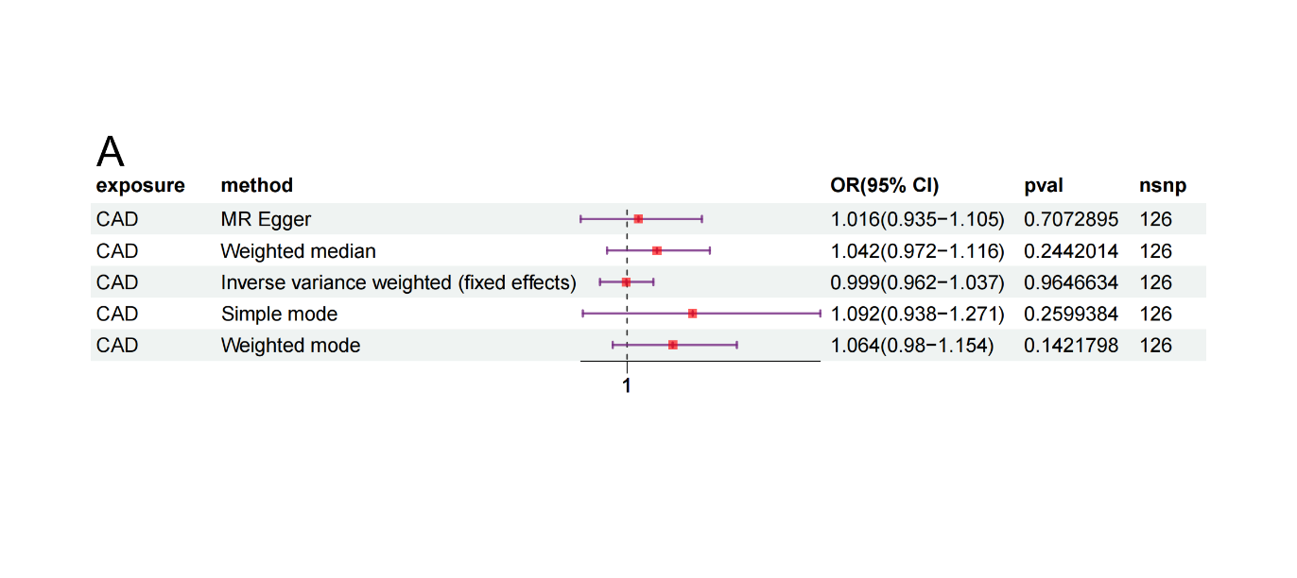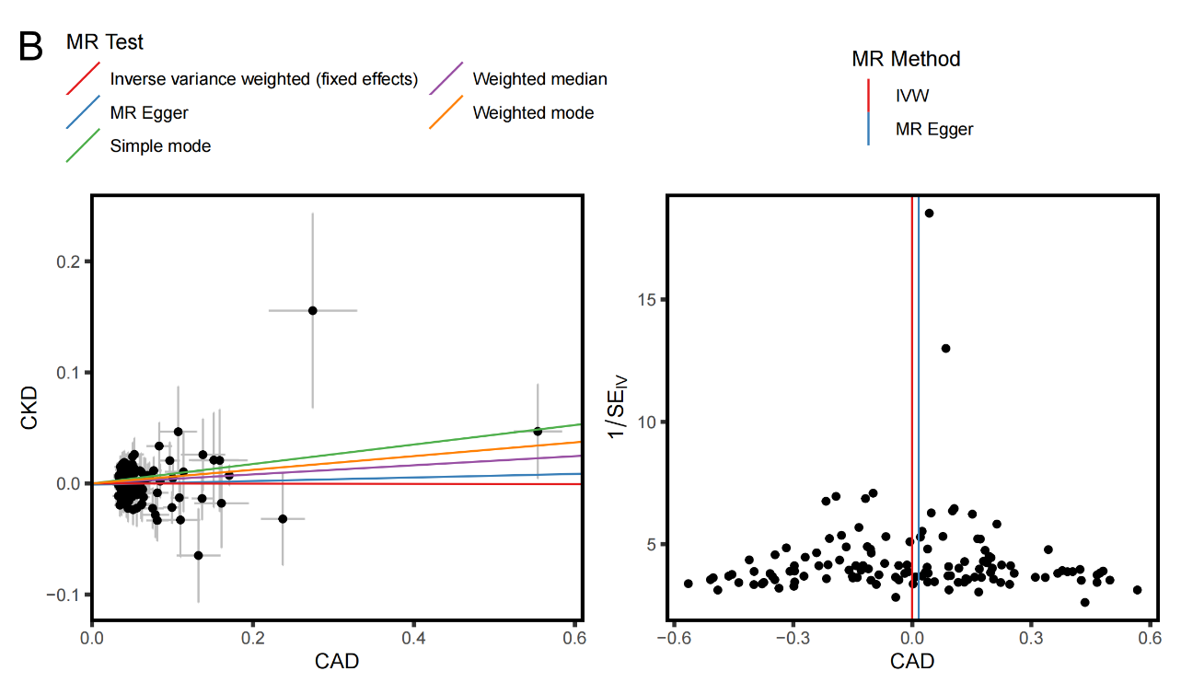

**Supplementary Figure S1.** MR analysis of CAD and CKD. A) Forest plot of the MR analysis; B) Sensitivity analysis (scatter plot, and funnel plot) for CAD–CKD.

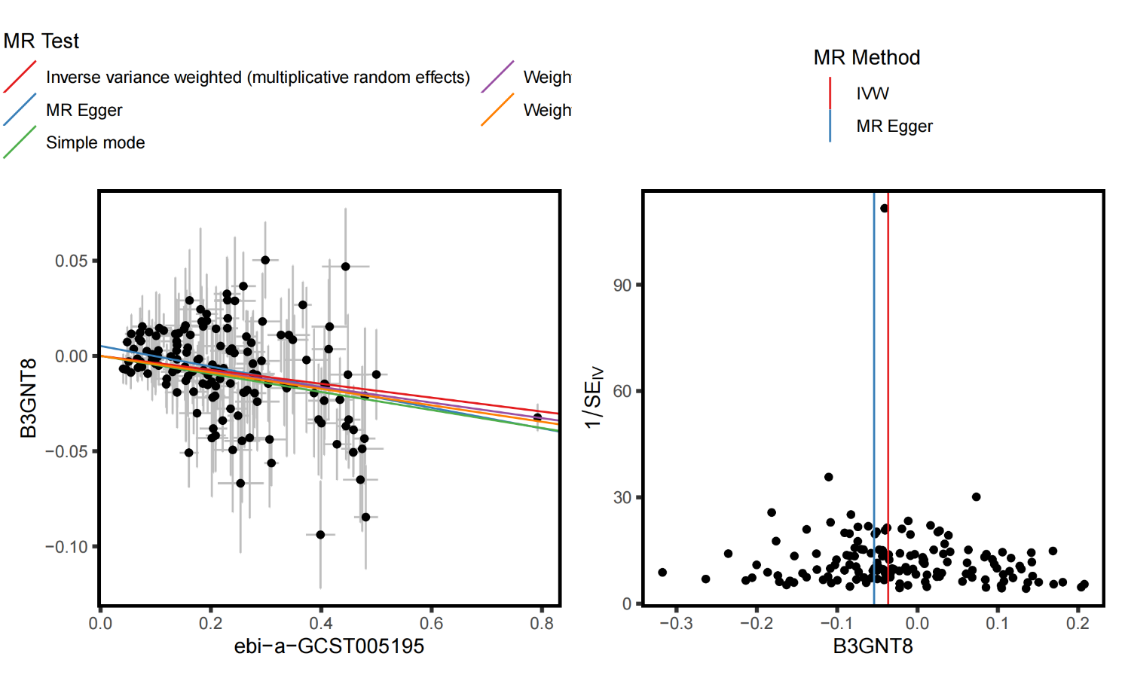

**Supplementary Figure S2.** Sensitivity analysis (scatter plot, and funnel plot) for B3GNT8.

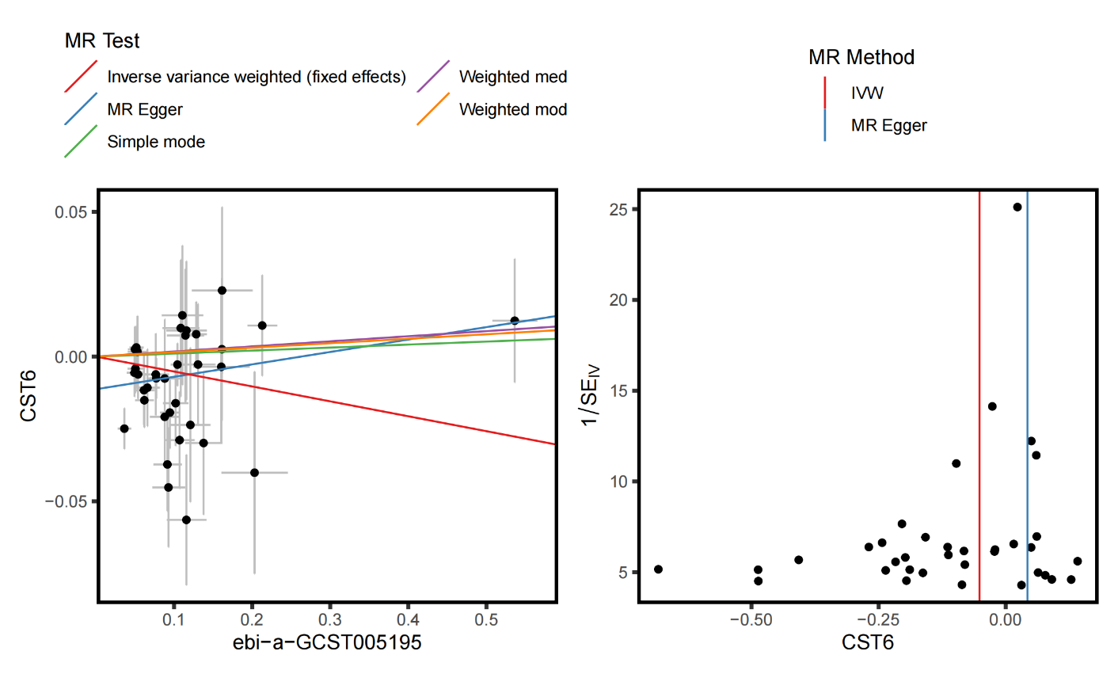

**Supplementary Figure S3.** Sensitivity analysis (scatter plot, and funnel plot) for CST6.

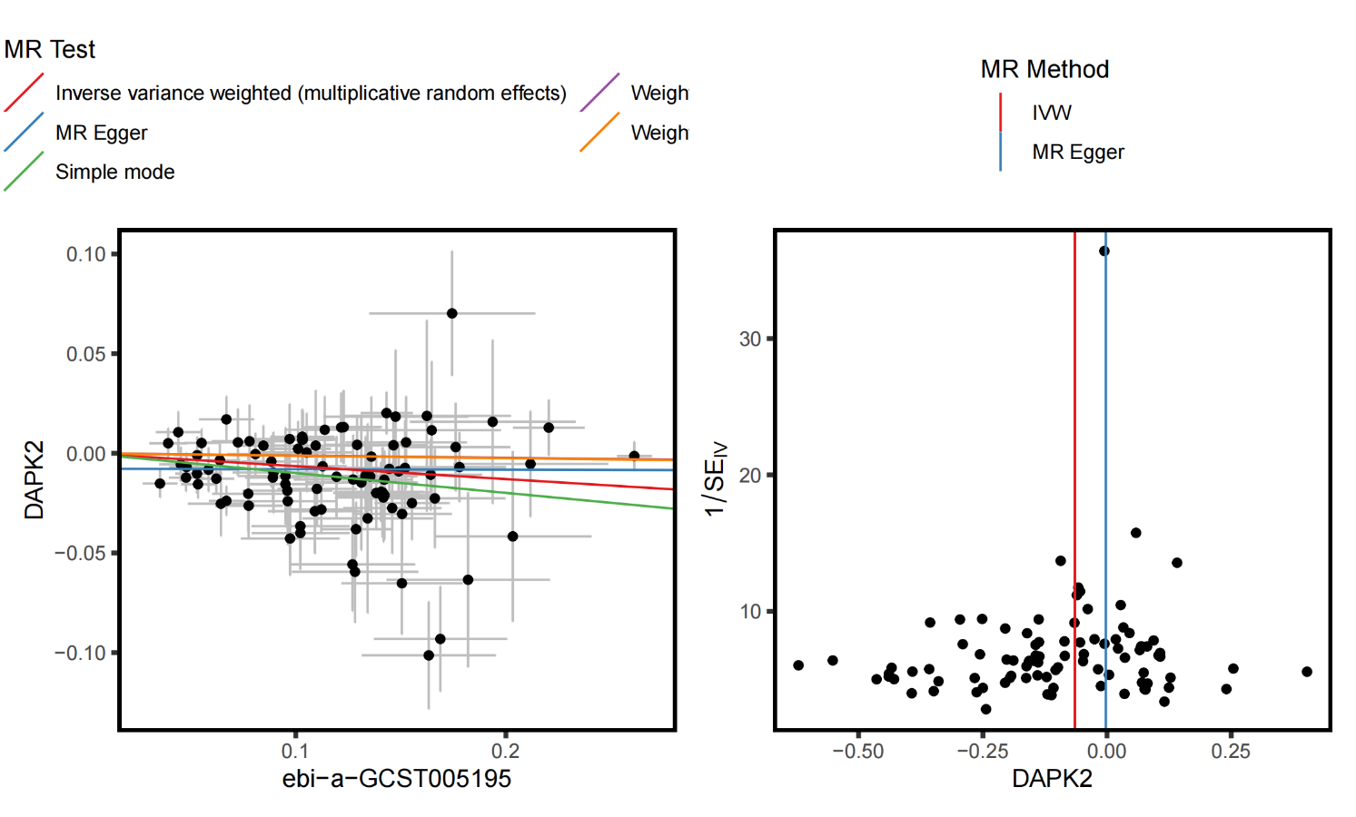

**Supplementary Figure S4.** Sensitivity analysis (scatter plot, and funnel plot) for DAPK2.

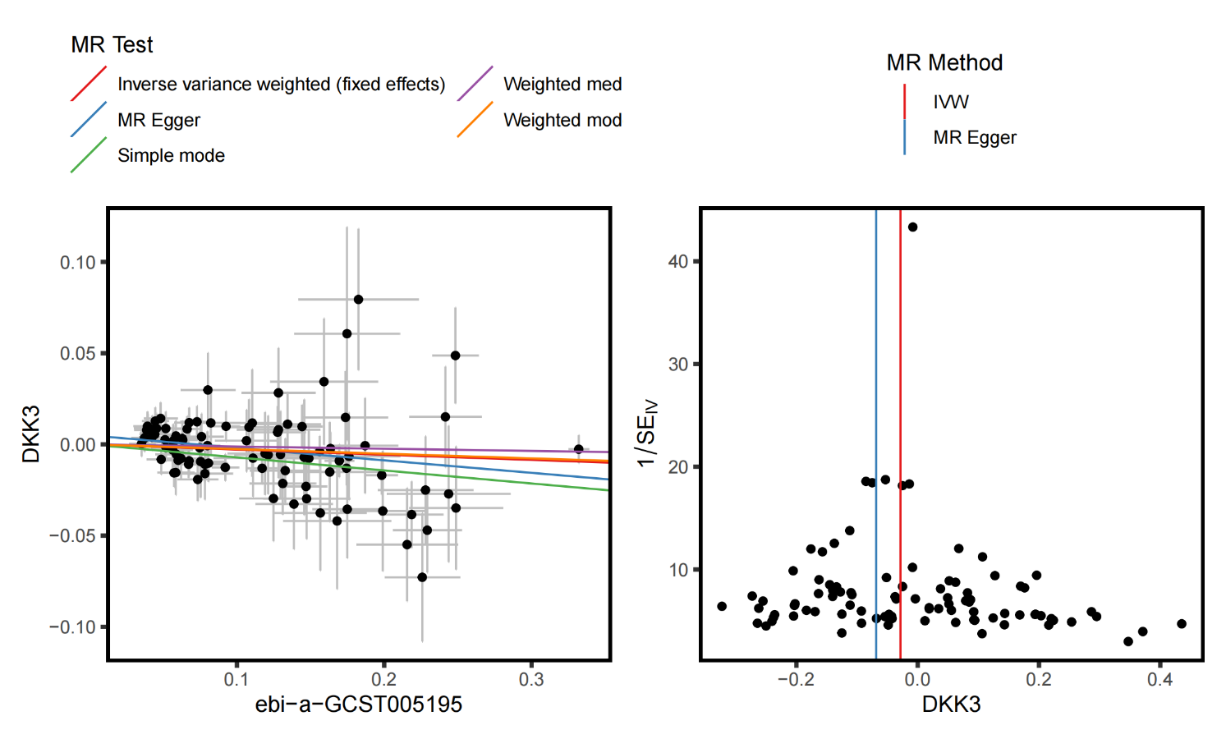

**Supplementary Figure S5.** Sensitivity analysis (scatter plot, and funnel plot) for DKK3.

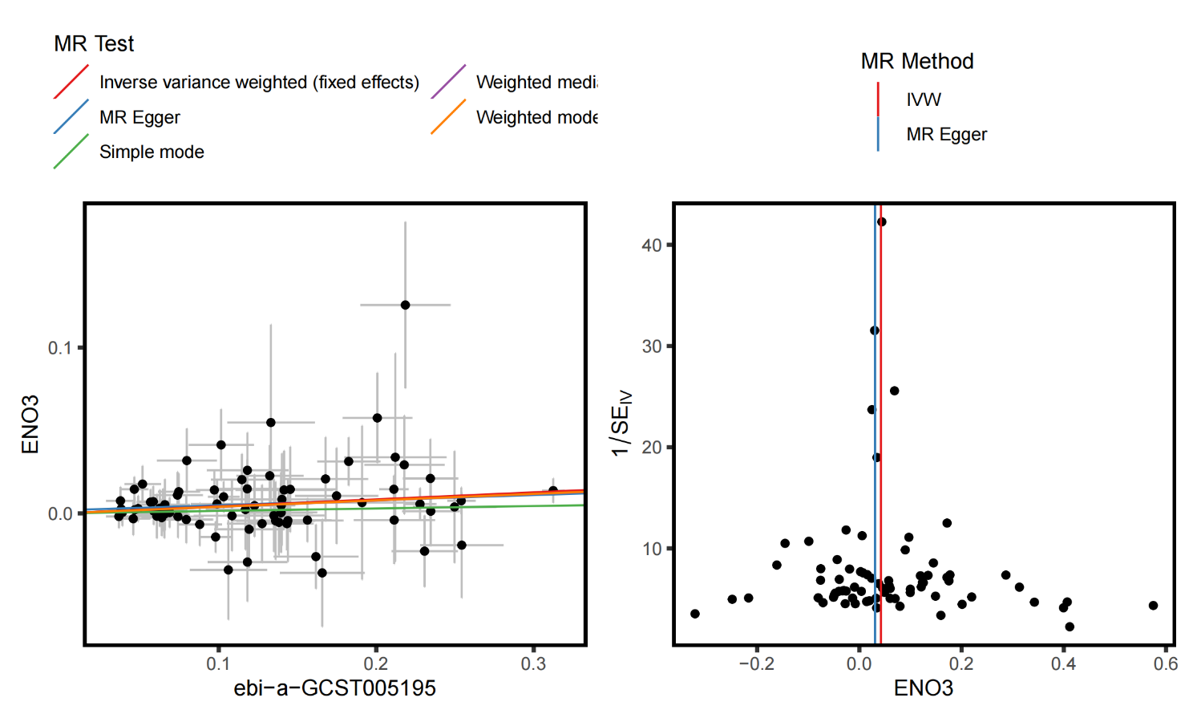

**Supplementary Figure S6.** Sensitivity analysis (scatter plot, and funnel plot) for ENO3.

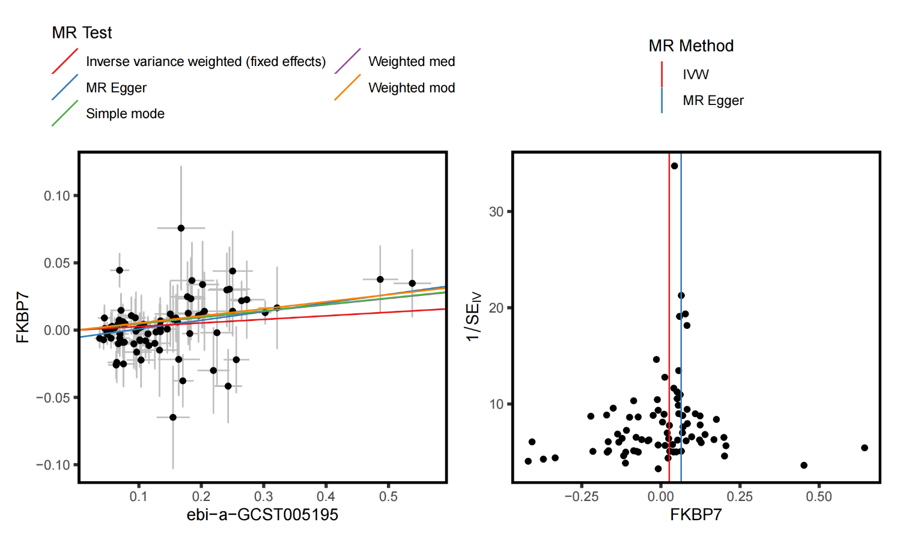

**Supplementary Figure S7.** Sensitivity analysis (scatter plot, and funnel plot) for EKBP7.

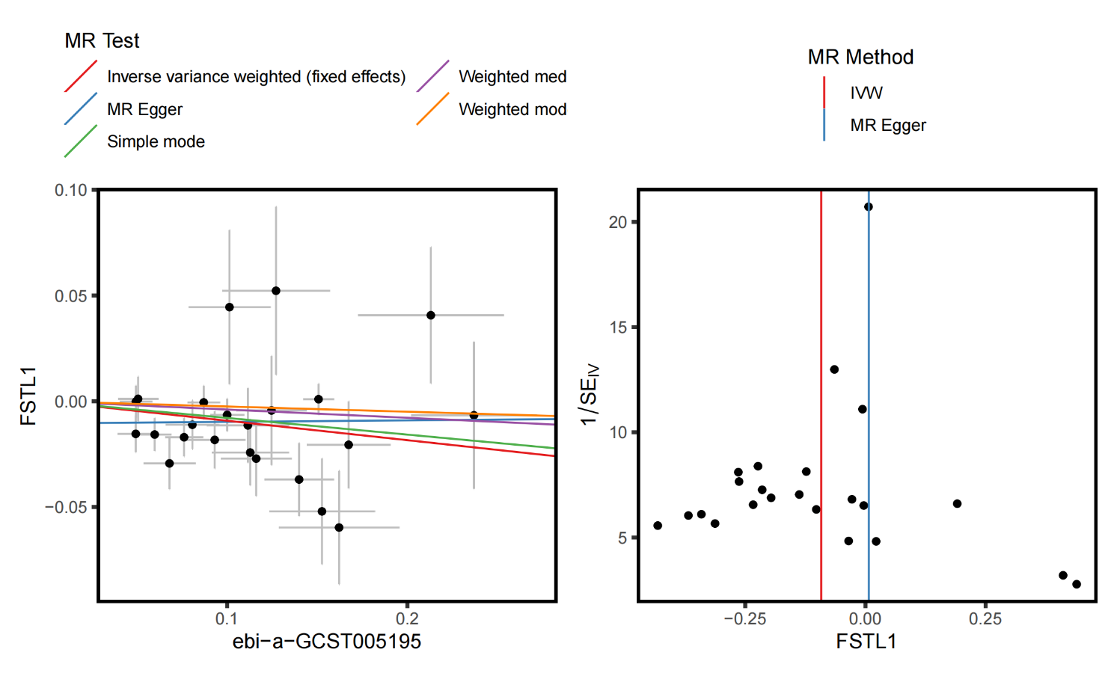

**Supplementary Figure S8.** Sensitivity analysis (scatter plot, and funnel plot) for FSTL1.

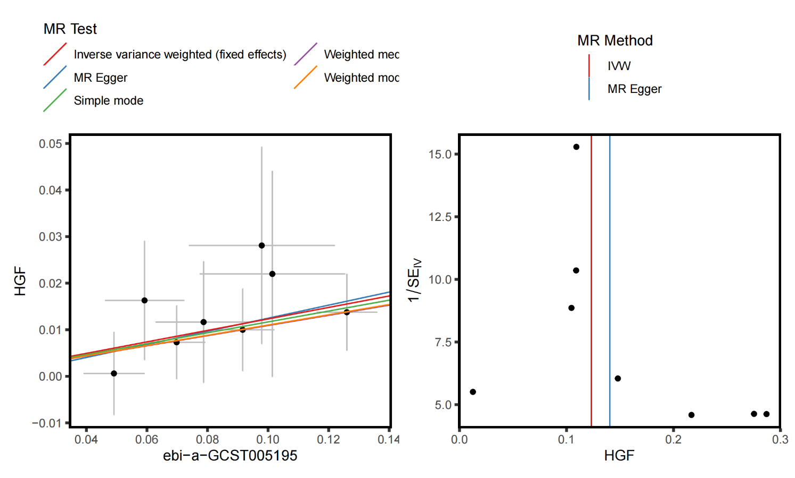

**Supplementary Figure S9.** Sensitivity analysis (scatter plot, and funnel plot) for HGF.

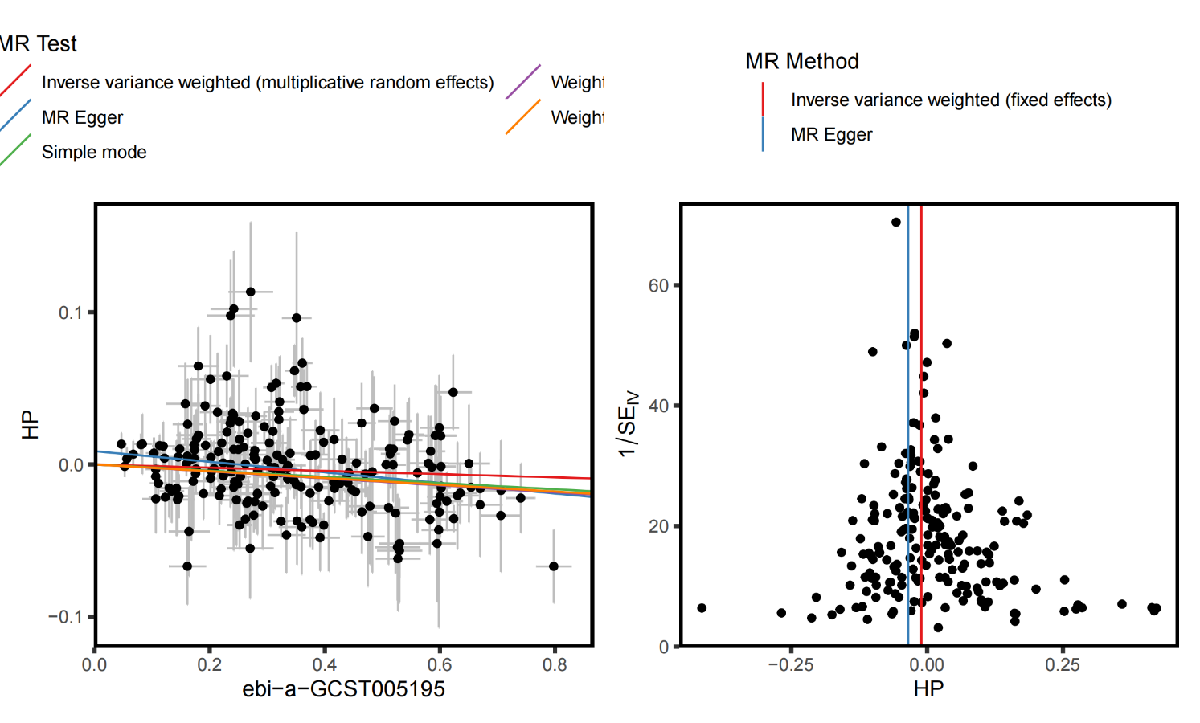

**Supplementary Figure S10.** Sensitivity analysis (scatter plot, and funnel plot) for HP.

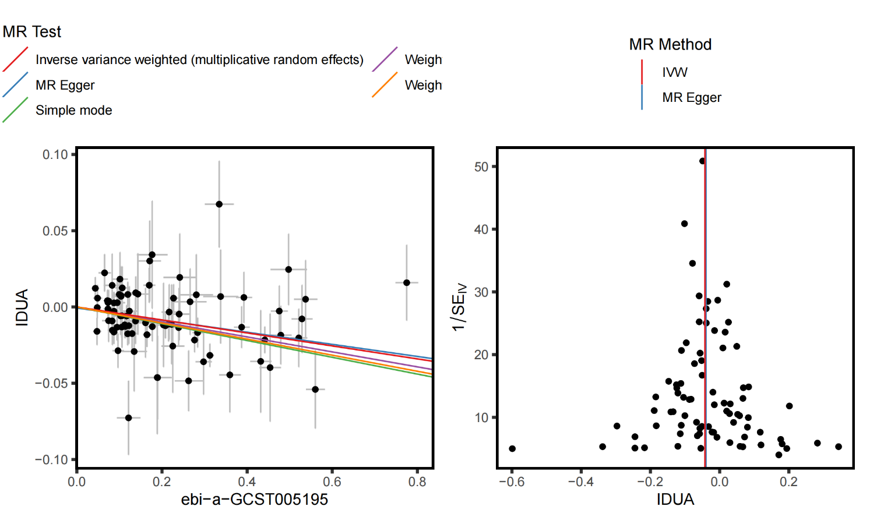

**Supplementary Figure S11.** Sensitivity analysis (scatter plot, and funnel plot) for IDUA.

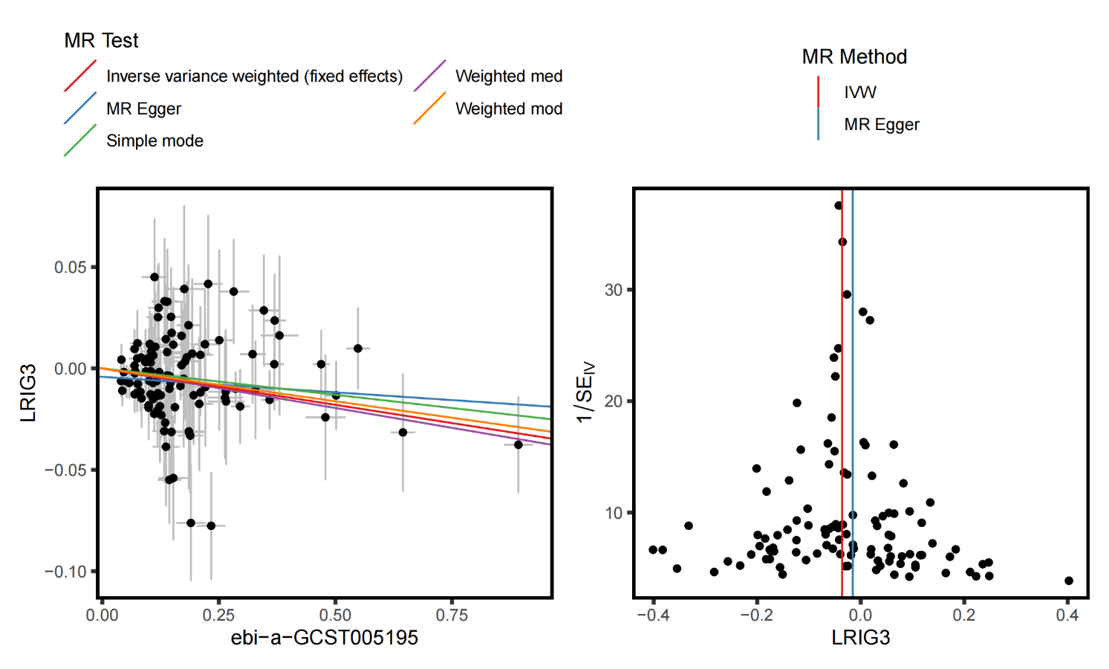

**Supplementary Figure S12.** Sensitivity analysis (scatter plot, and funnel plot) for LRIG3.

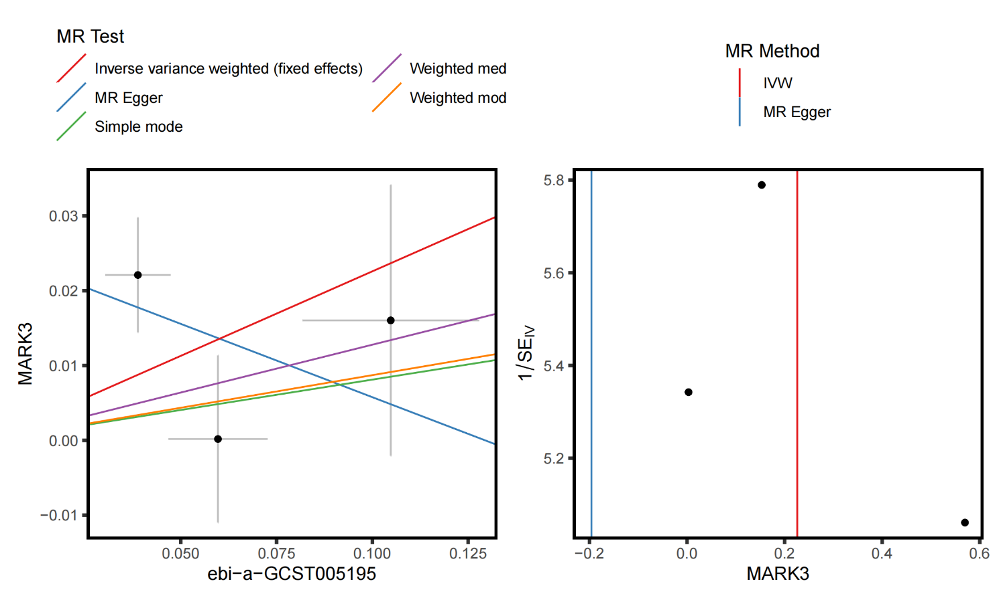

**Supplementary Figure S13.** Sensitivity analysis (scatter plot, and funnel plot) for MARK3.

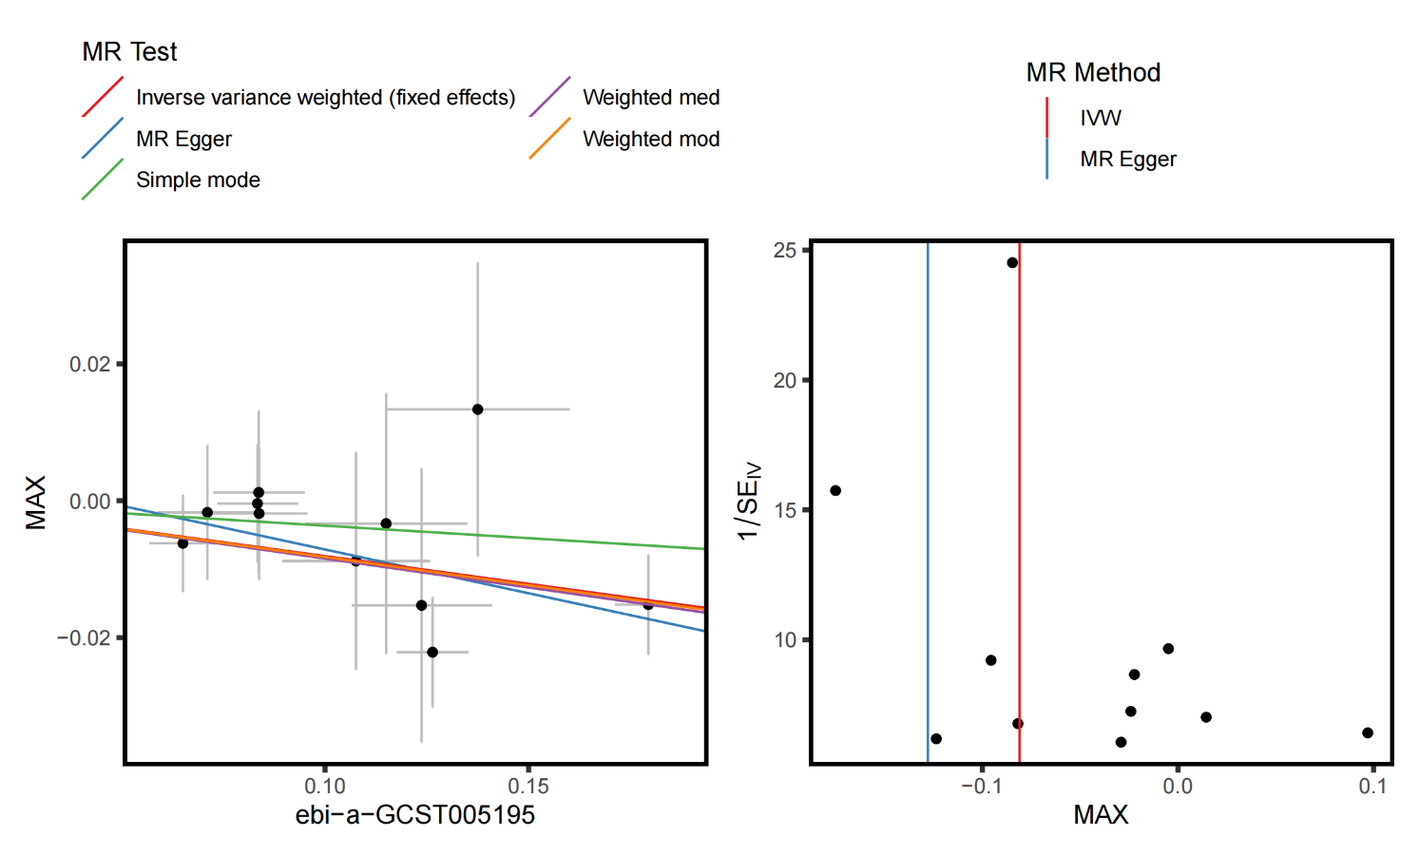

**Supplementary Figure S14.** Sensitivity analysis (scatter plot, and funnel plot) for MAX.

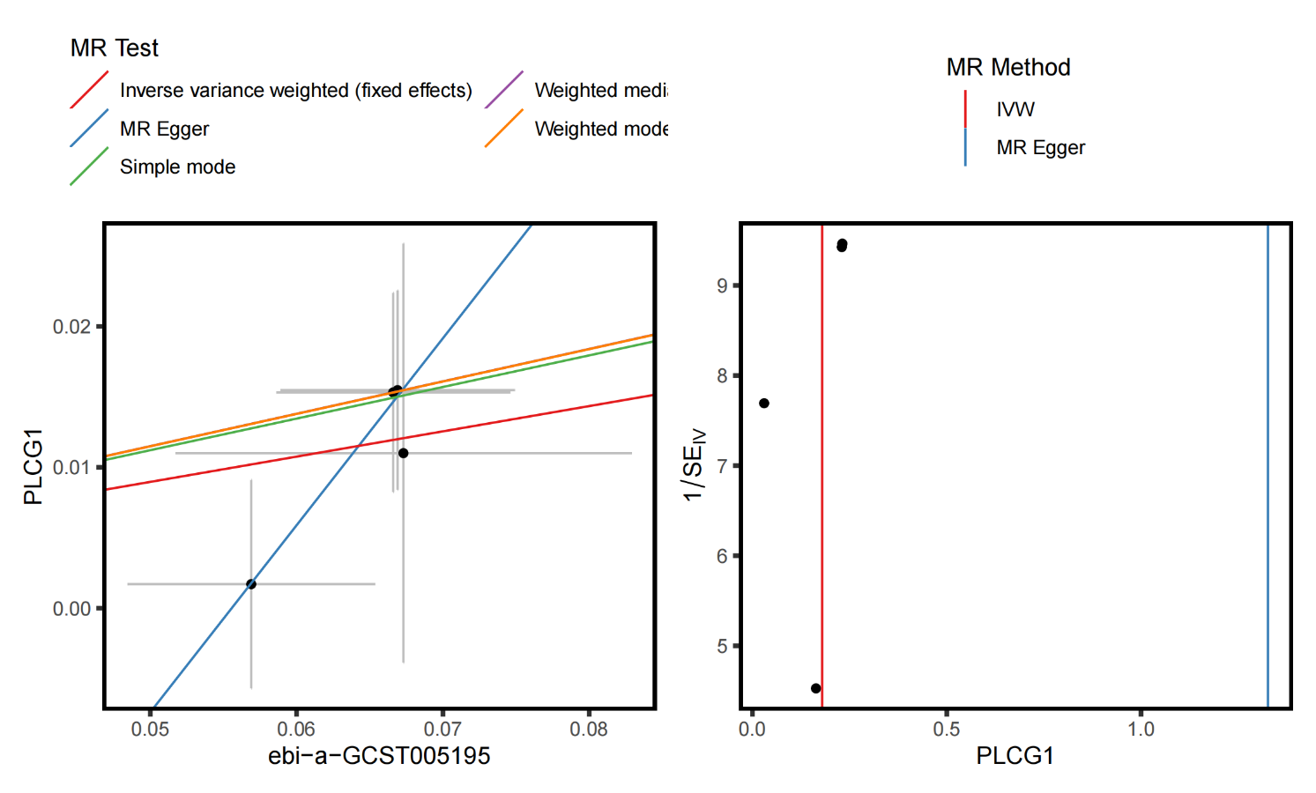

**Supplementary Figure S15.** Sensitivity analysis (scatter plot, and funnel plot) for PLCG1.

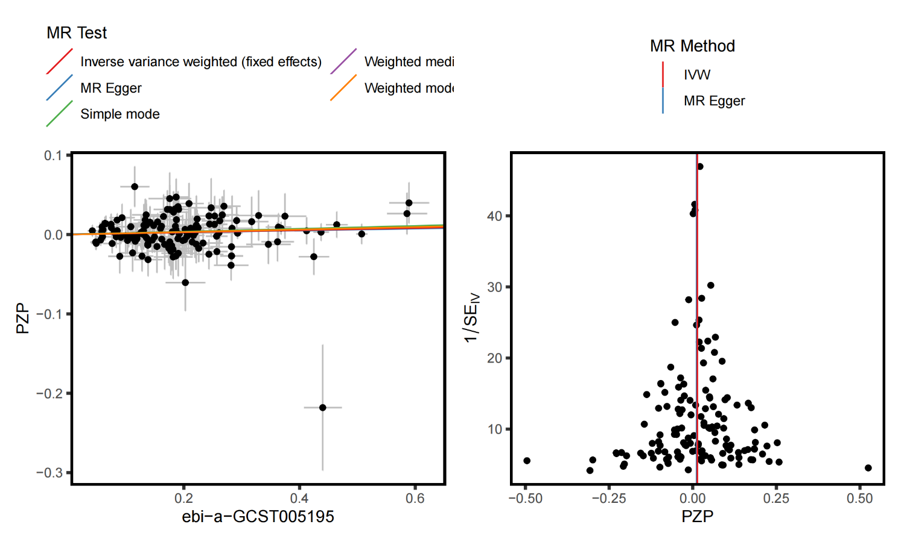

**Supplementary Figure S16.** Sensitivity analysis (scatter plot, and funnel plot) for PZP.

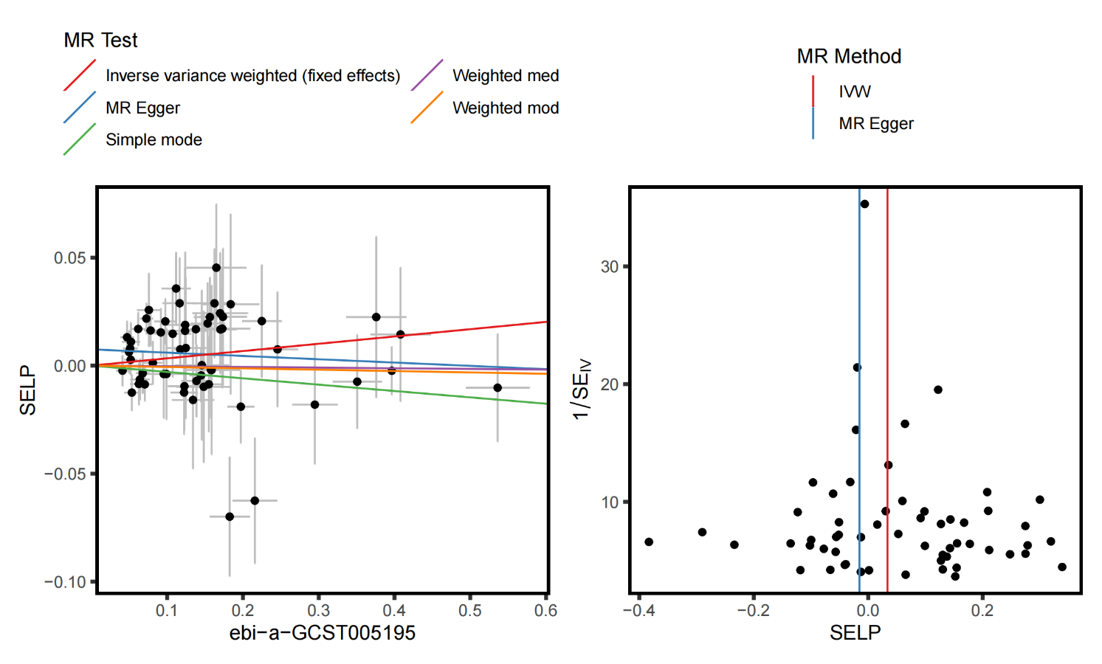

**Supplementary Figure S17.** Sensitivity analysis (scatter plot, and funnel plot) for SELP.

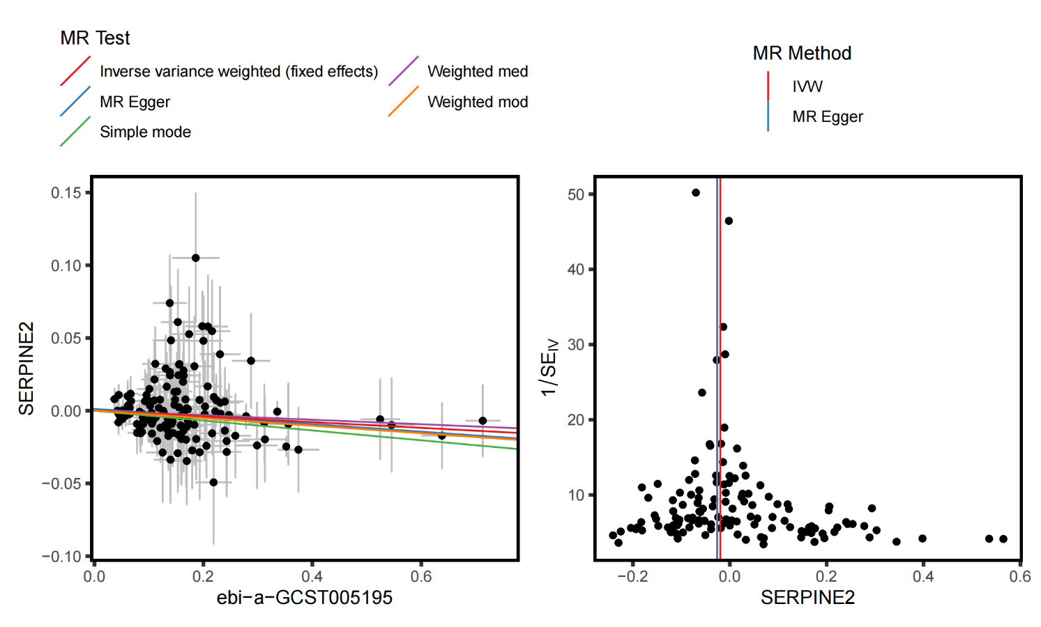

**Supplementary Figure S18.** Sensitivity analysis (scatter plot, and funnel plot) for SERPINE2.

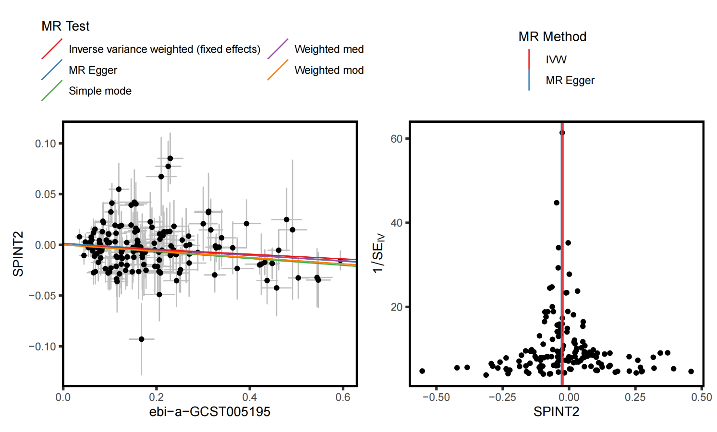

**Supplementary Figure S19.** Sensitivity analysis (scatter plot, and funnel plot) for SPINT2.

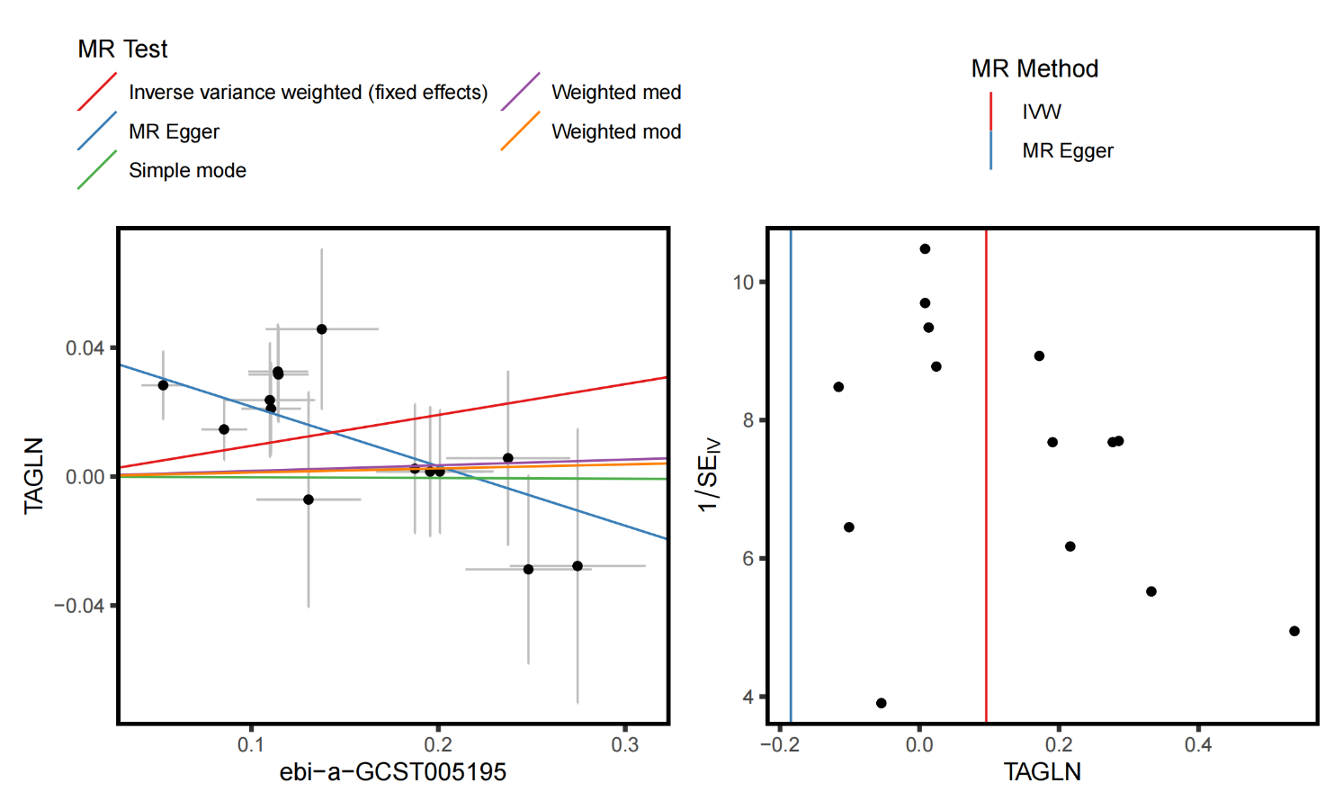

**Supplementary Figure S20.** Sensitivity analysis (scatter plot, and funnel plot) for TAGLN.

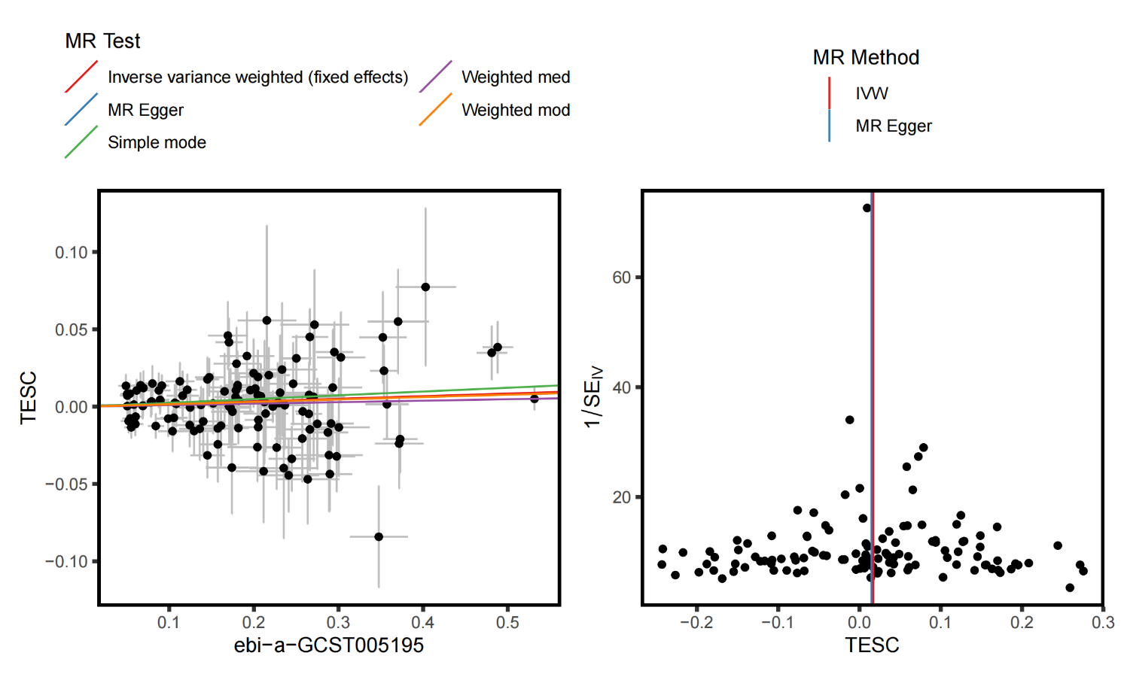

**Supplementary Figure S21.** Sensitivity analysis (scatter plot, and funnel plot) for TESC.

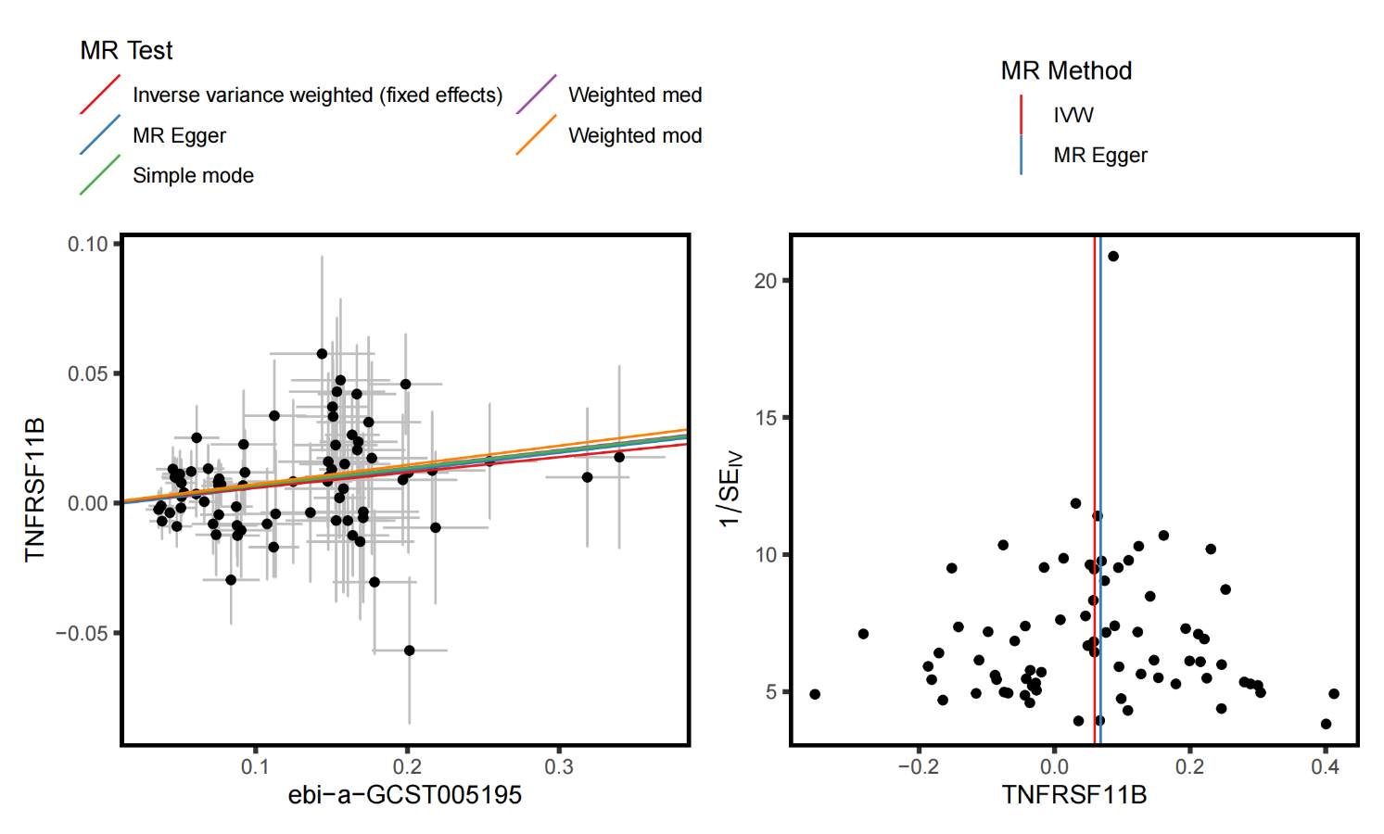

**Supplementary Figure S22.** Sensitivity analysis (scatter plot, and funnel plot) for TNFRSF11B.

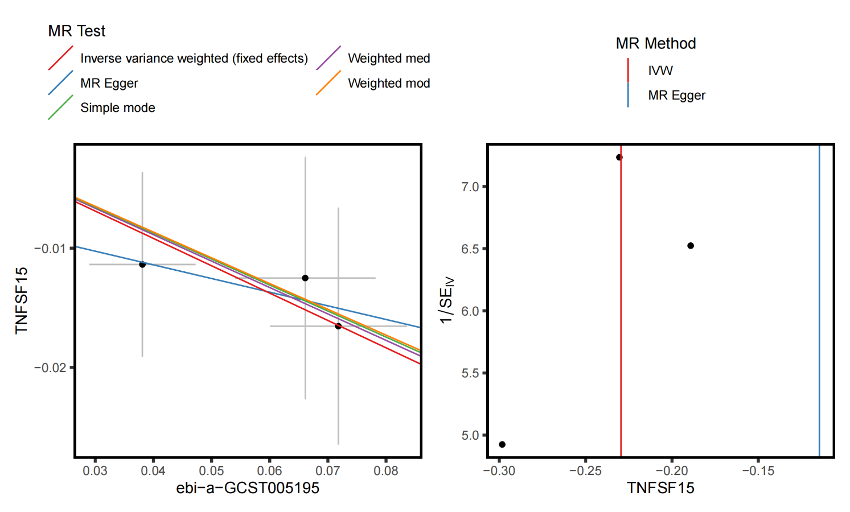

**Supplementary Figure S23.** Sensitivity analysis (scatter plot, and funnel plot) for TNFSF15.

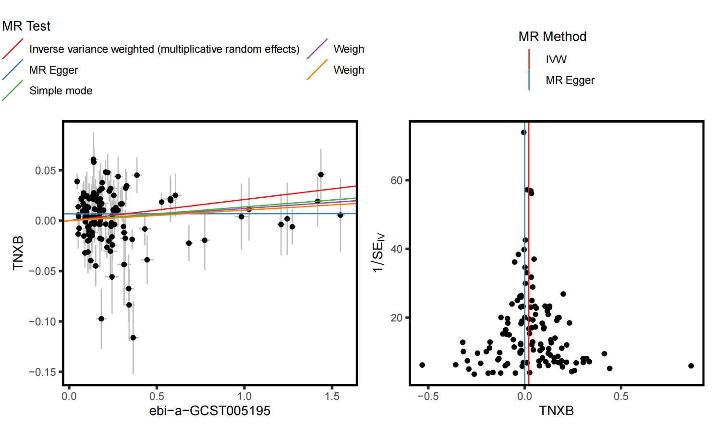

**Supplementary Figure S24.** Sensitivity analysis (scatter plot, and funnel plot) for TNXB.

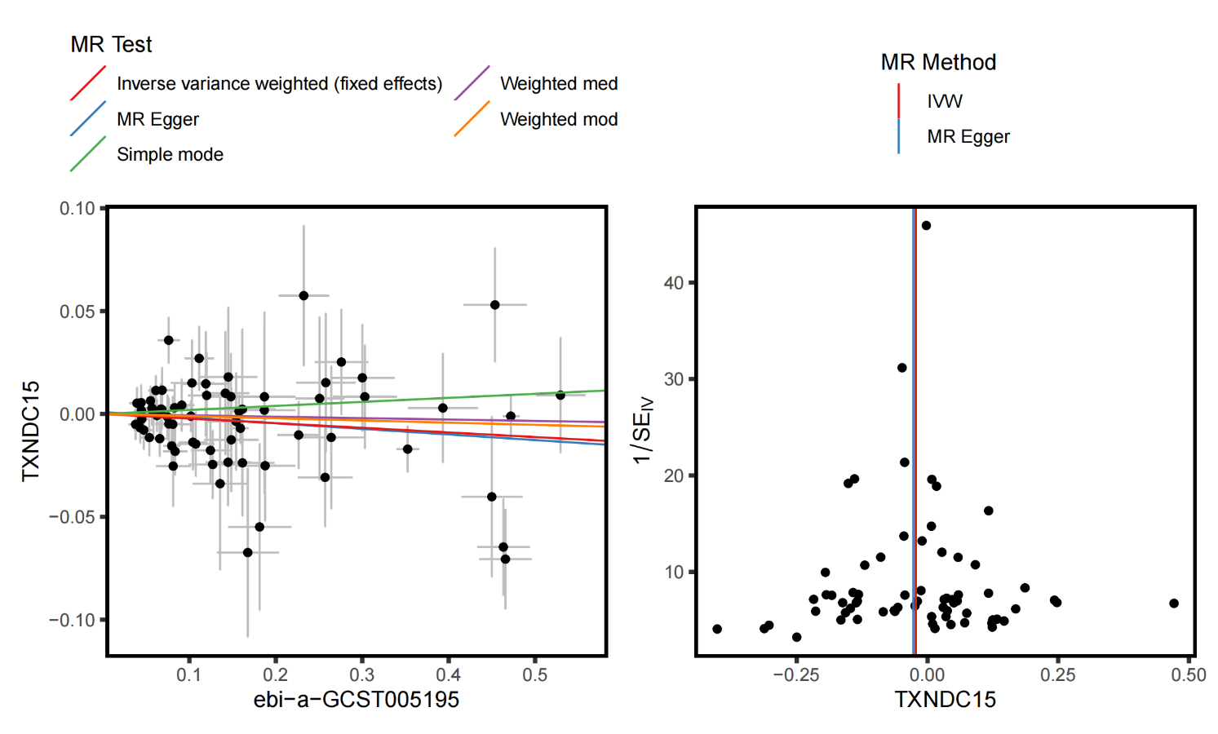

**Supplementary Figure S25.** Sensitivity analysis (scatter plot, and funnel plot) for TXNDC15.

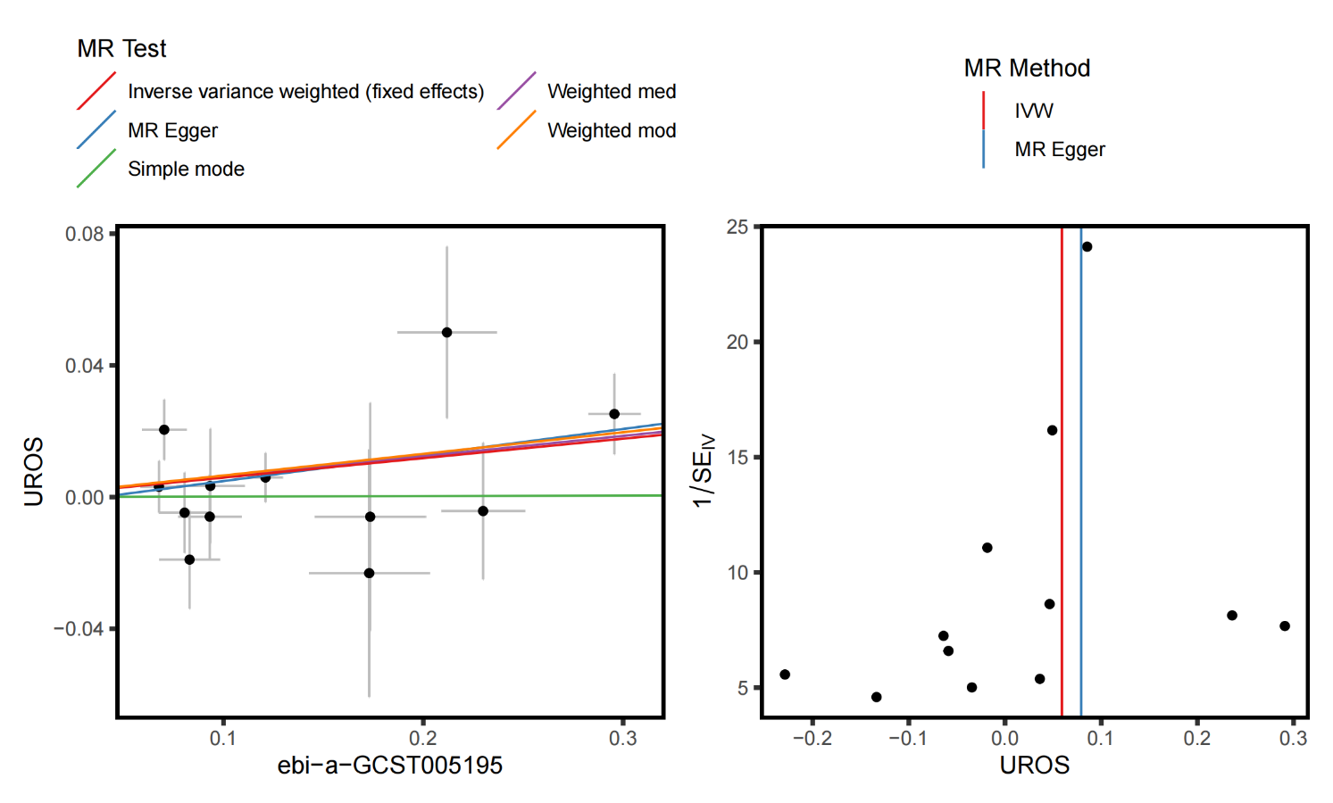

**Supplementary Figure S26.** Sensitivity analysis (scatter plot, and funnel plot) for UROS.

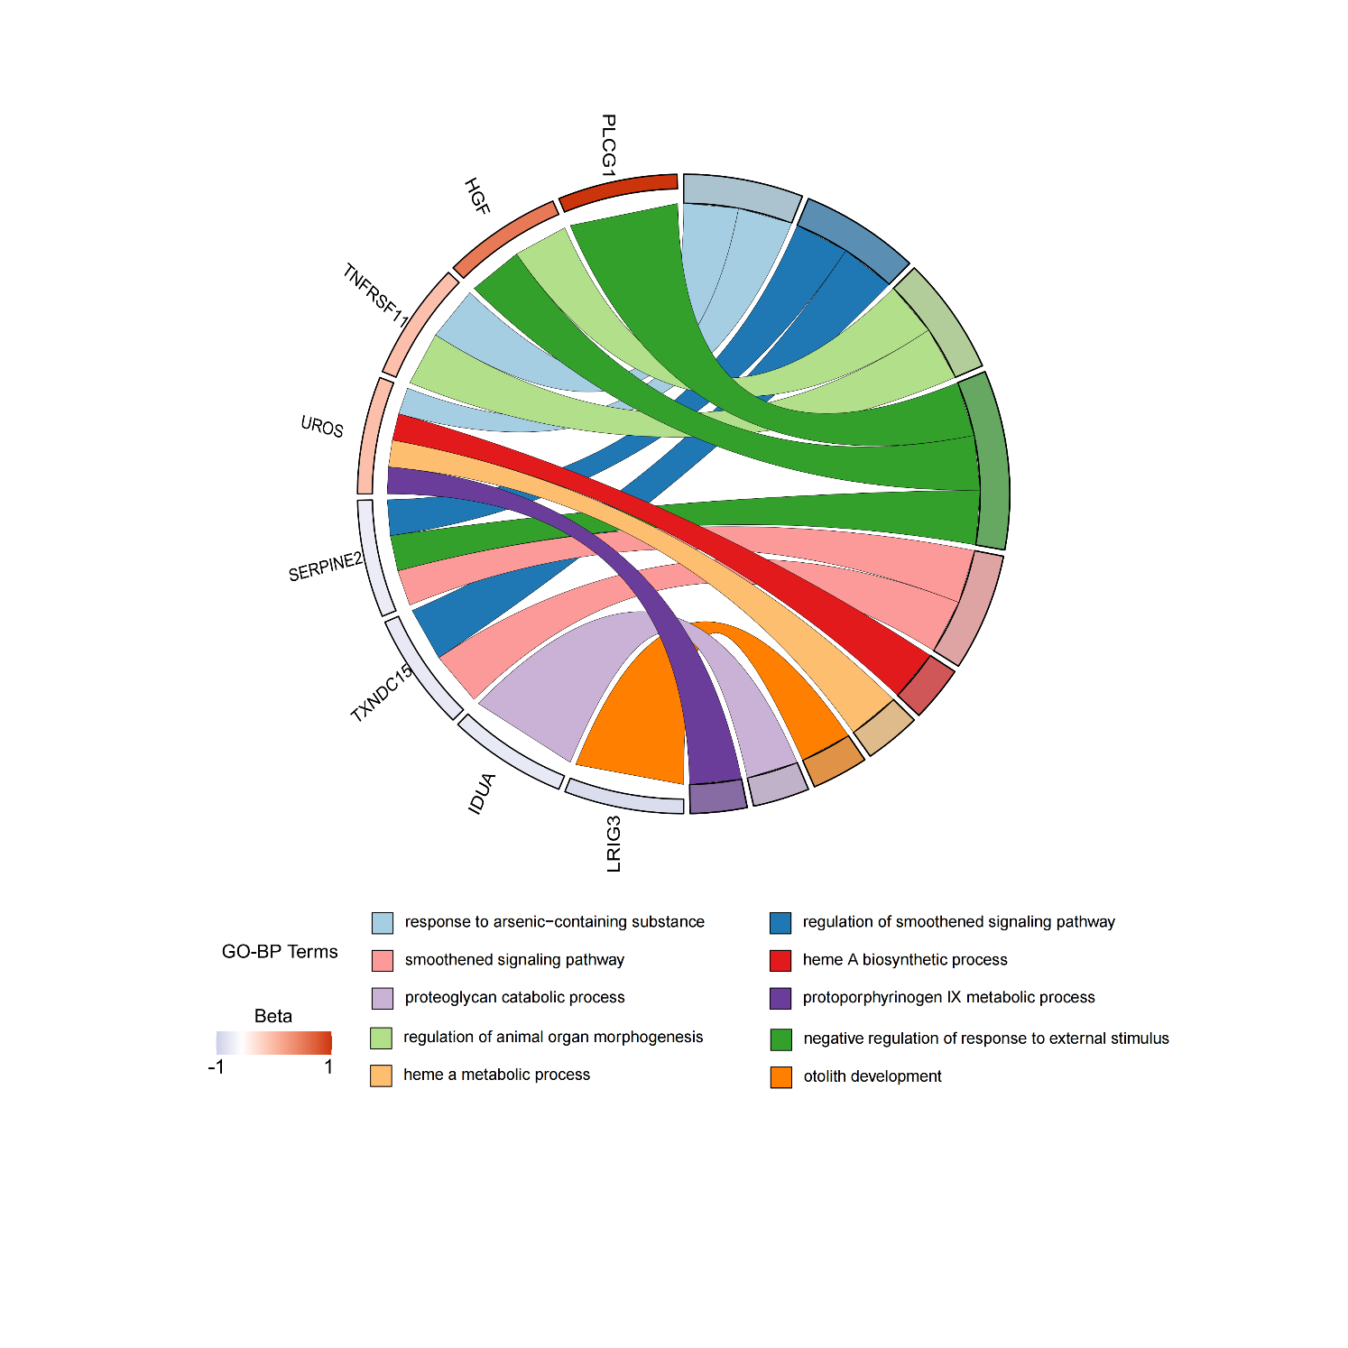

**Supplementary Figure S27.** Chord Diagram of Gene Ontology - Biological Process (GO - BP) Enrichment Analysis.

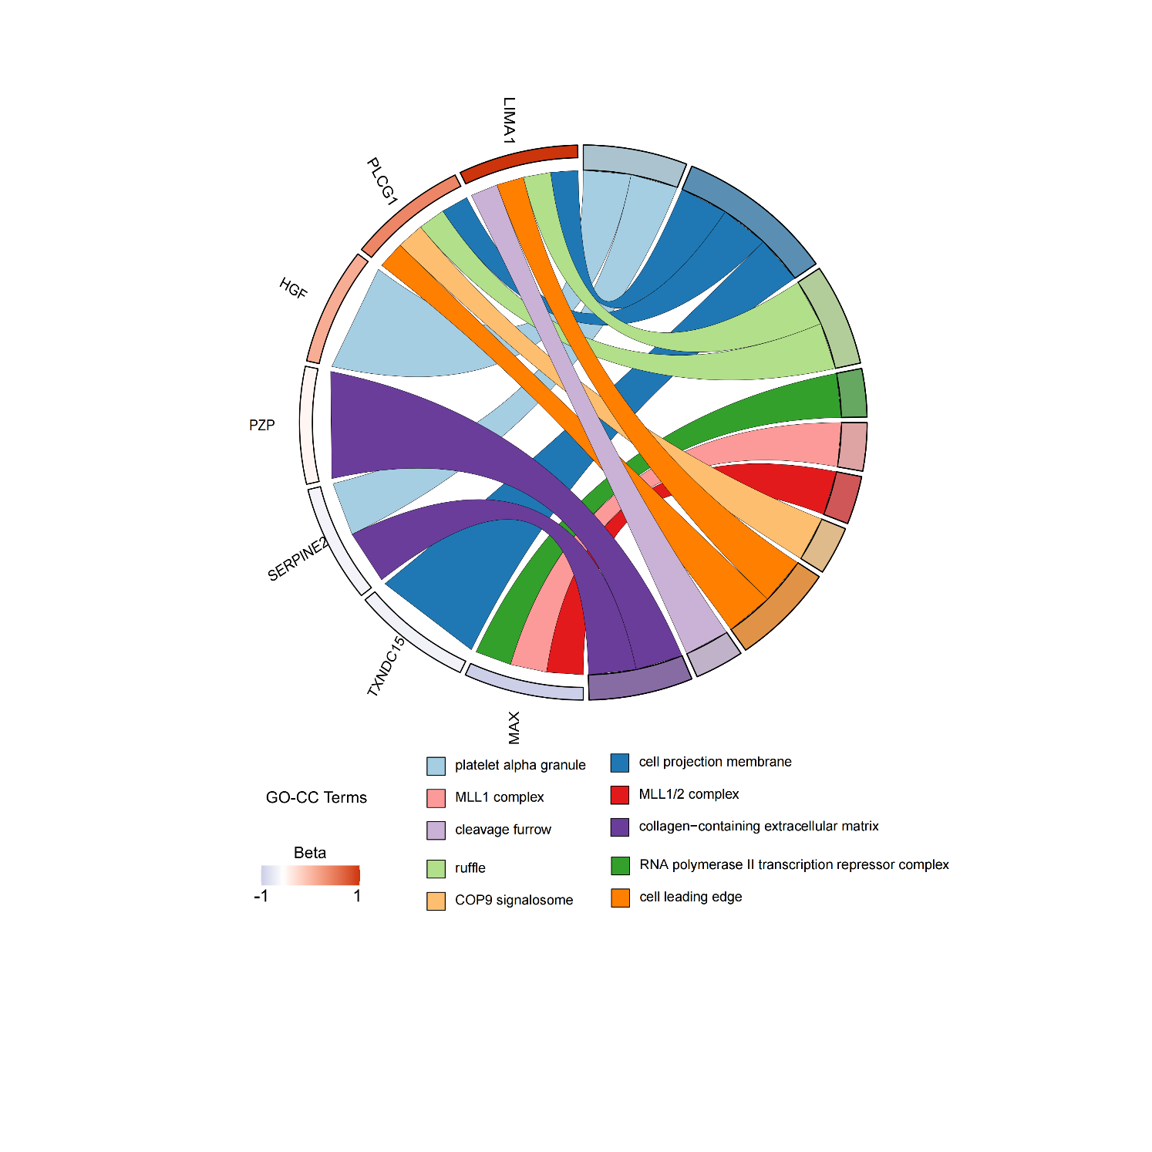

**Supplementary Figure S28.** Chord Diagram of Gene Ontology - Biological Process (GO - CC) Enrichment Analysis.

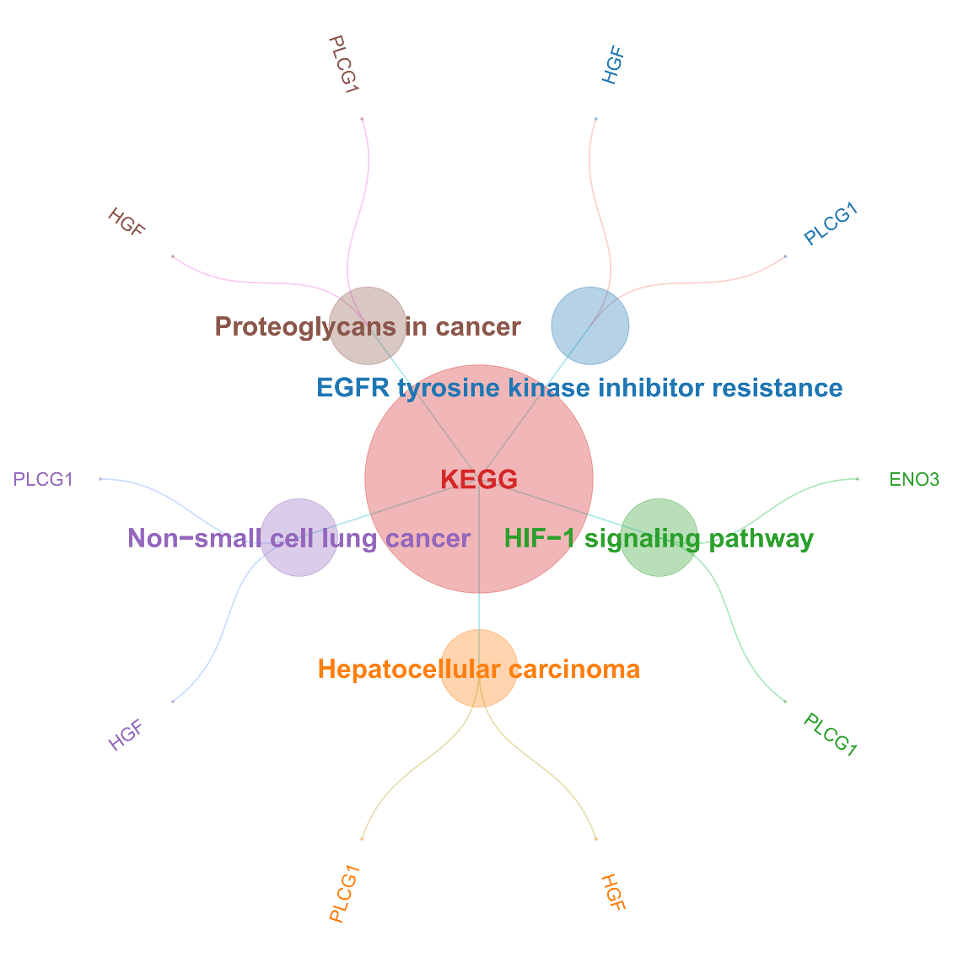

**Supplementary Figure S29.** GO enrichment results of core proteins.

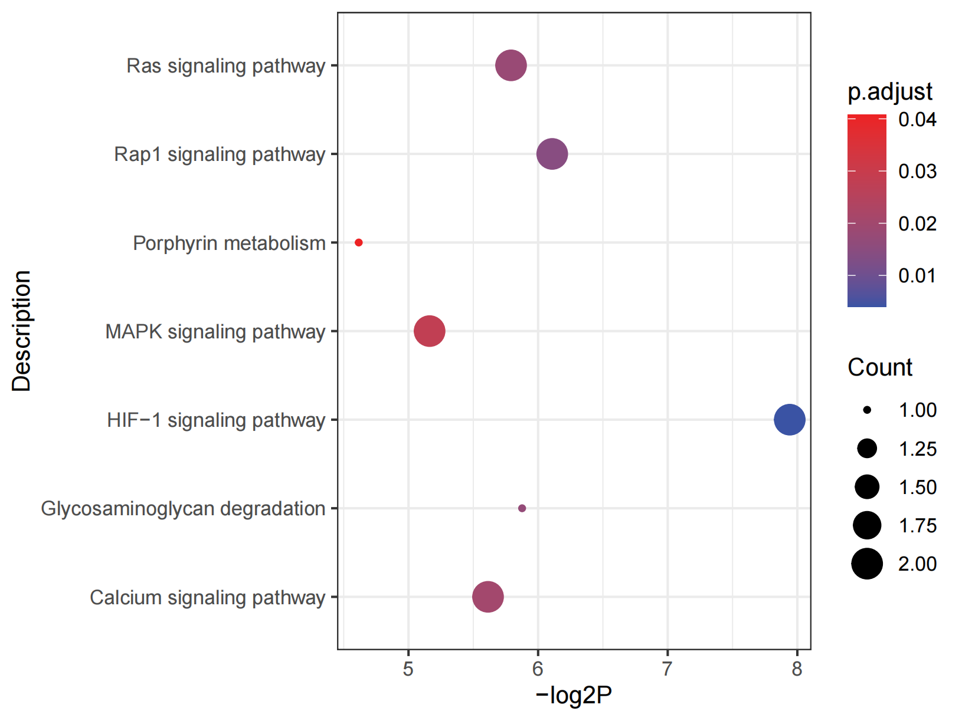

**Supplementary Figure S30.** KEGG Enrichment Analysis Bubble Plot.

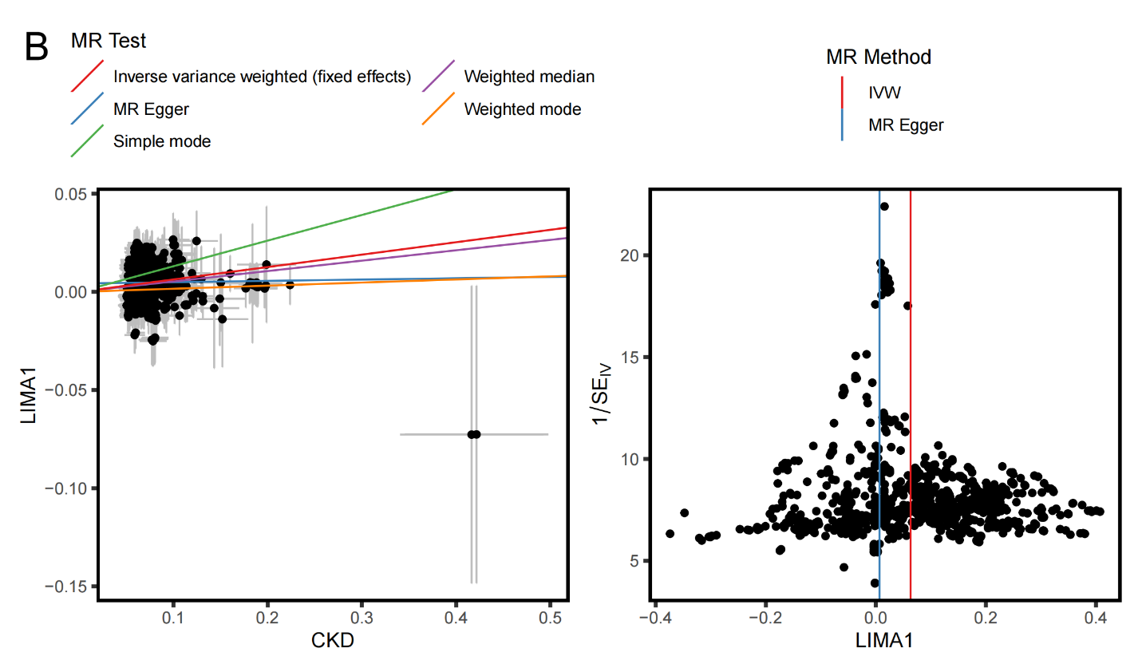

**Supplementary Figure S31.** Sensitivity analysis (scatter plot, and funnel plot) for LIMA1.

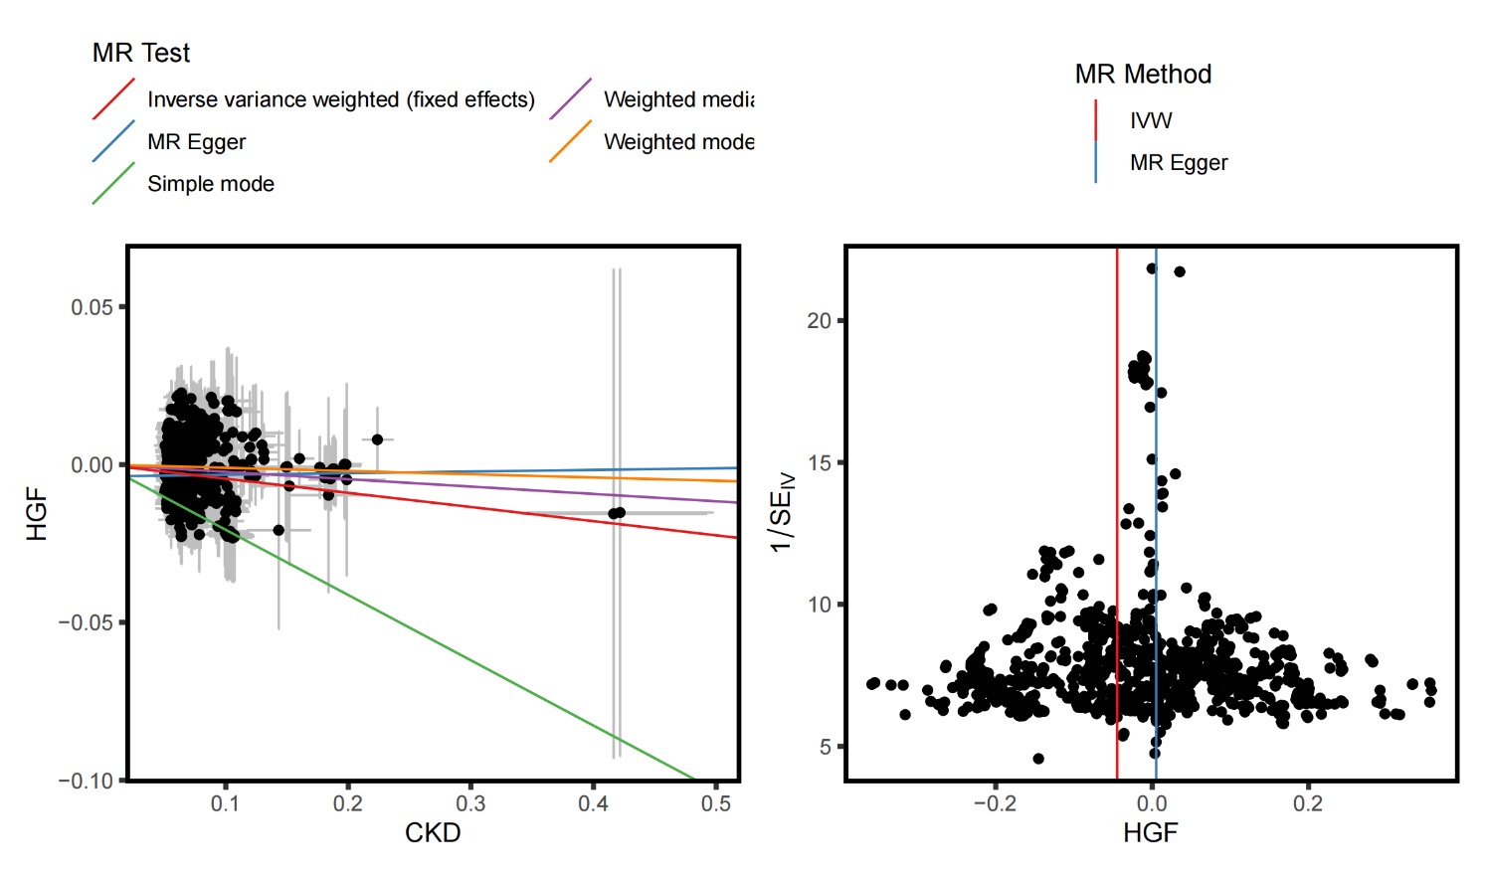

**Supplementary Figure S32.** Sensitivity analysis (scatter plot, and funnel plot) for HGF.

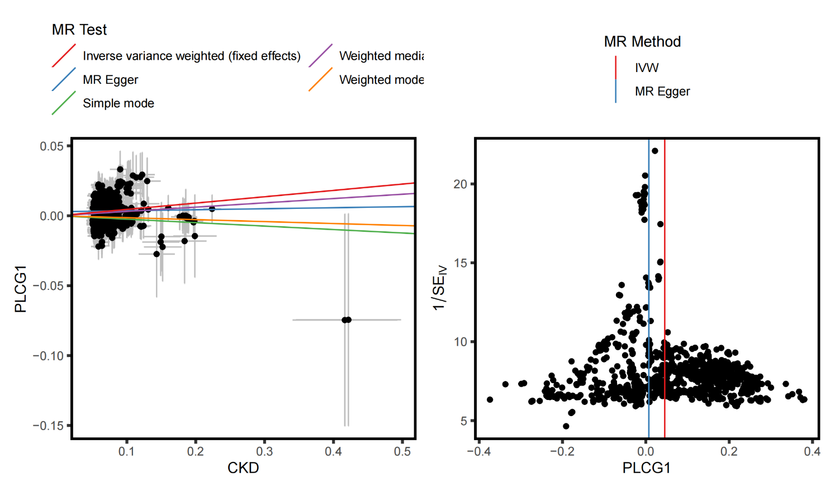

**Supplementary Figure S33.** Sensitivity analysis (scatter plot, and funnel plot) for PLCG1.

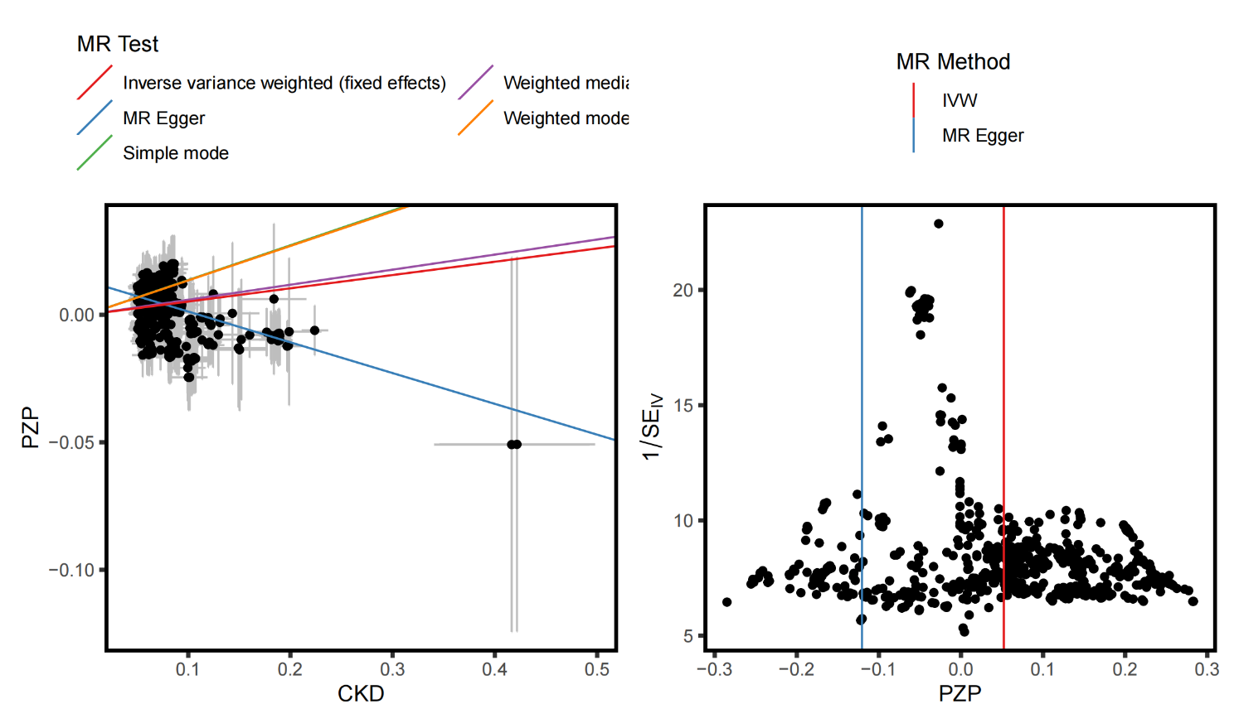

**Supplementary Figure S34.** Sensitivity analysis (scatter plot, and funnel plot) for PZP.

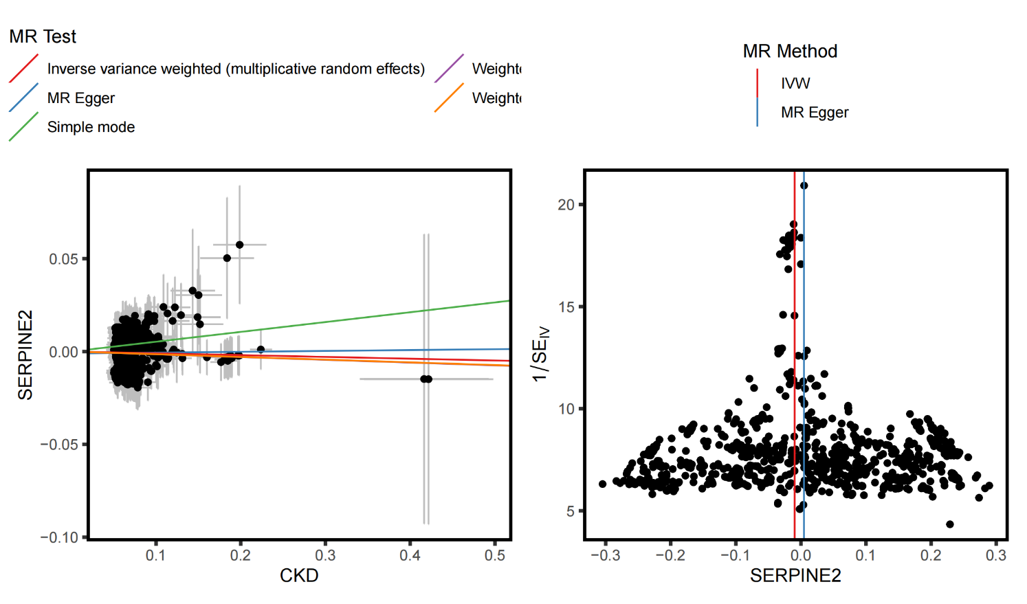

**Supplementary Figure S35.** Sensitivity analysis (scatter plot, and funnel plot) for SERPINE2.

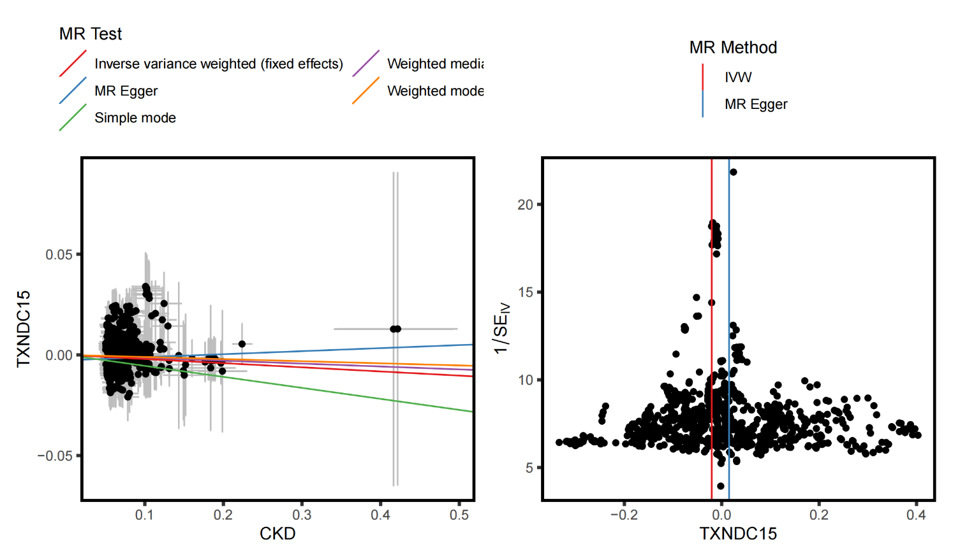

**Supplementary Figure S36.** Sensitivity analysis (scatter plot, and funnel plot) for TXNDC15.

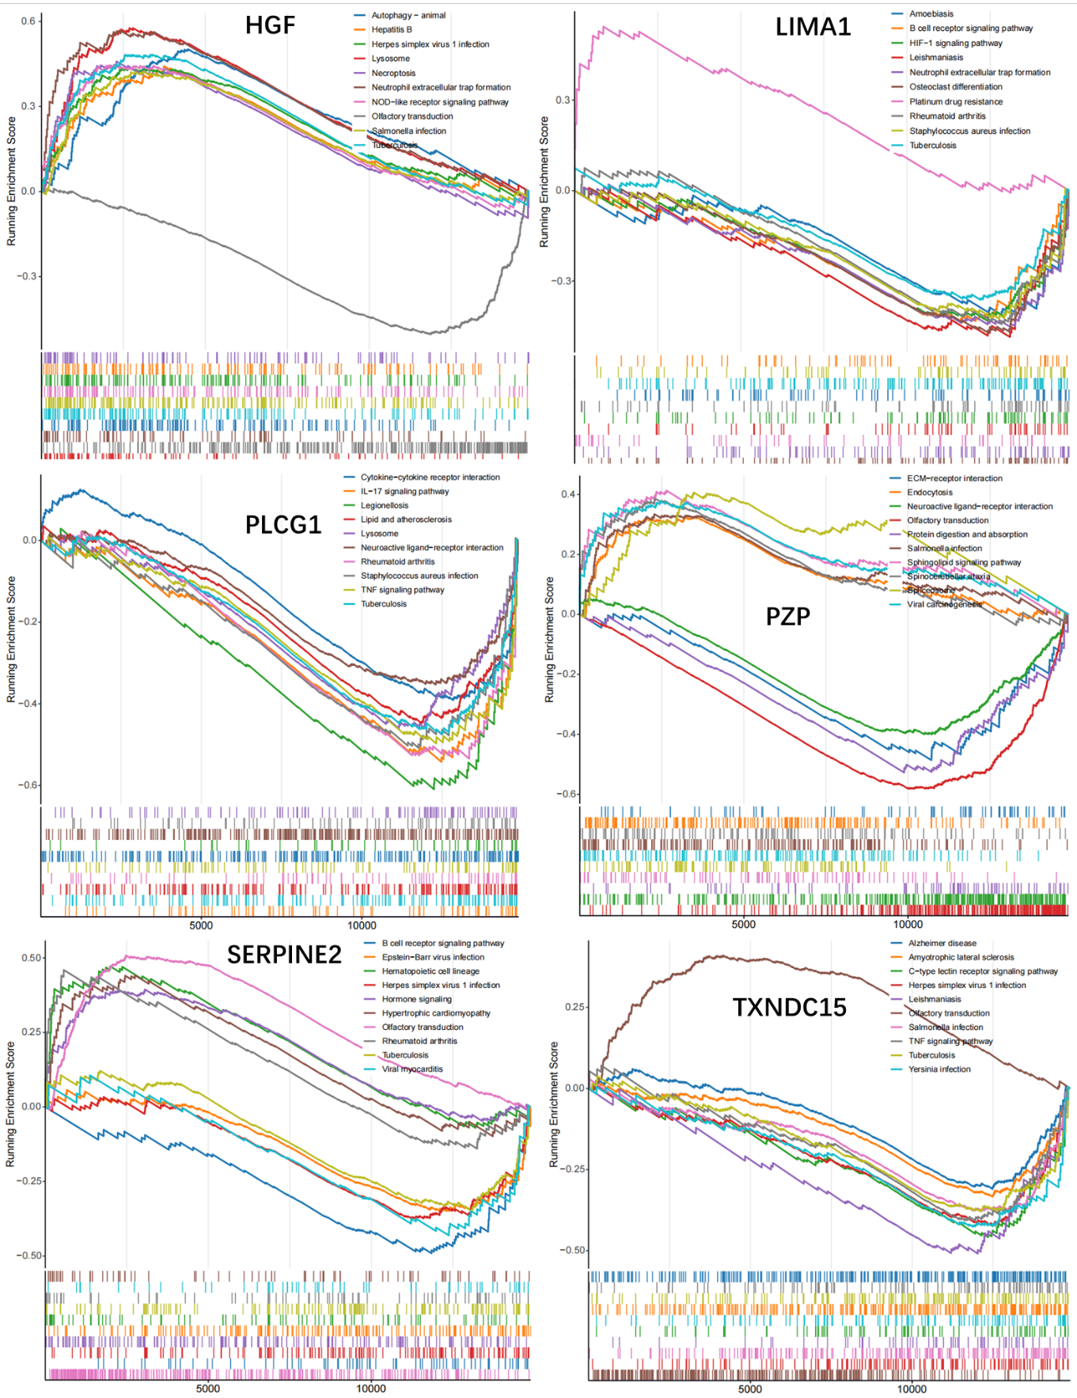

**Supplementary Figure S37.** Ridge plot of CAD-GSEA enrichment results.

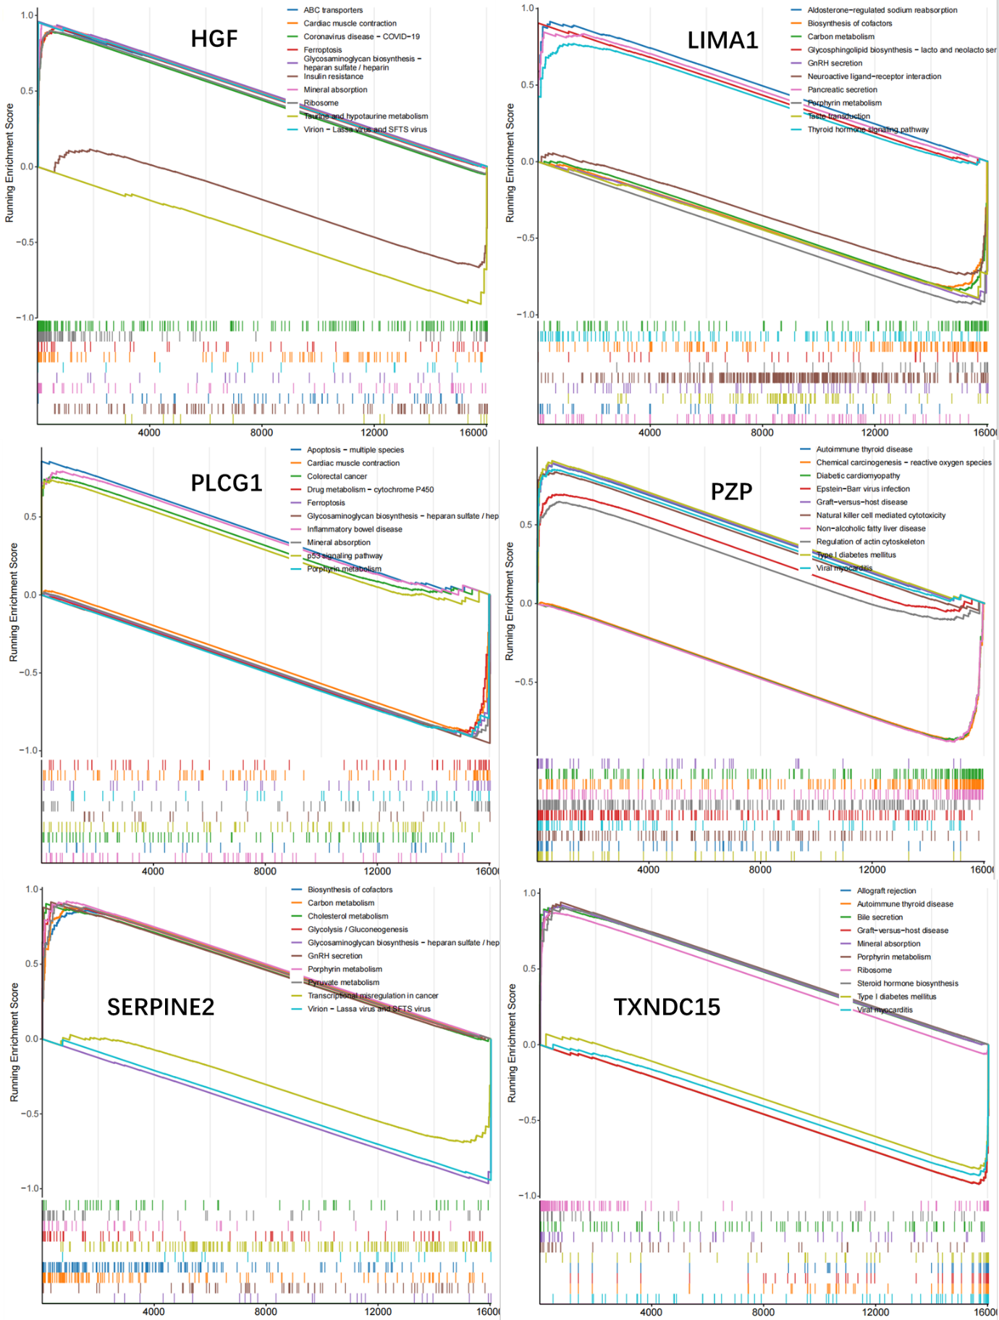

**Supplementary Figure S38.** **Ridge plot of CKD-GSEA enrichment results**

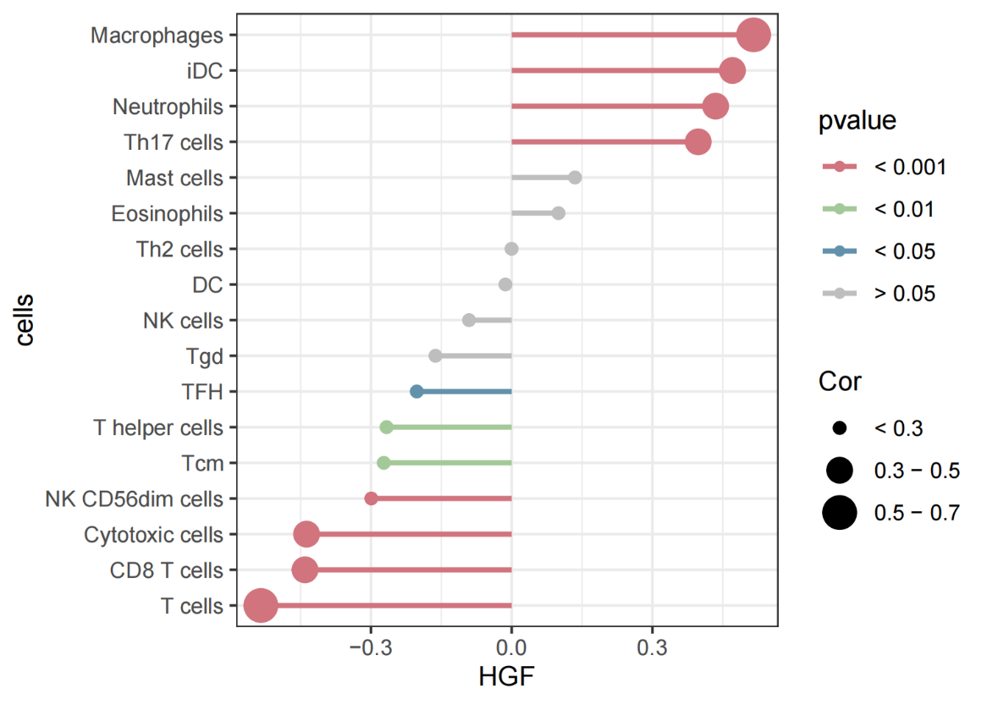

**Supplementary Figure S39.** Lollipop chart showing how HGF is correlated with immune cells in CAD.

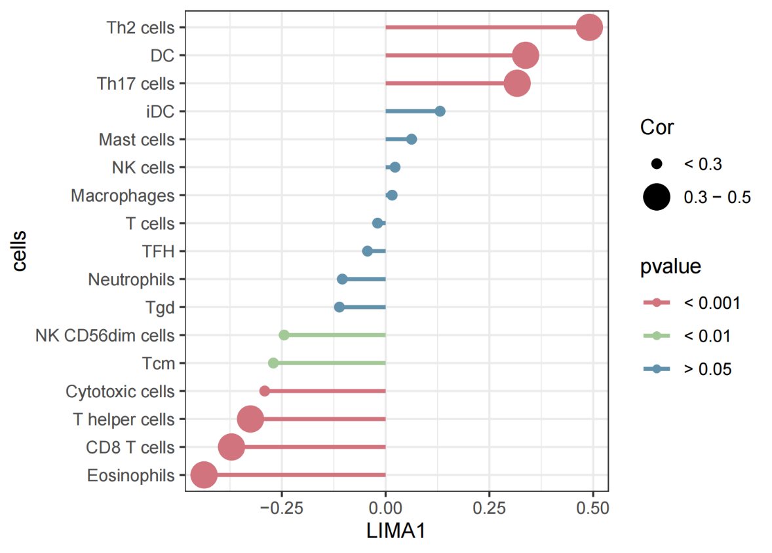

**Supplementary Figure S40.** Lollipop chart showing how LIMA1 is correlated with immune cells in CAD.

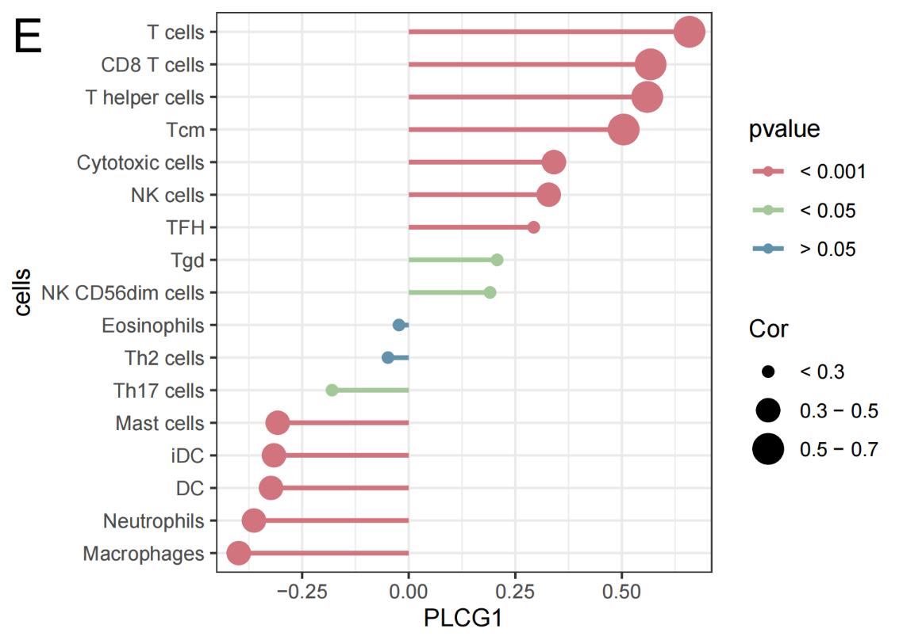

**Supplementary Figure S41.** Lollipop chart showing how PLCG1 is correlated with immune cells in CAD.

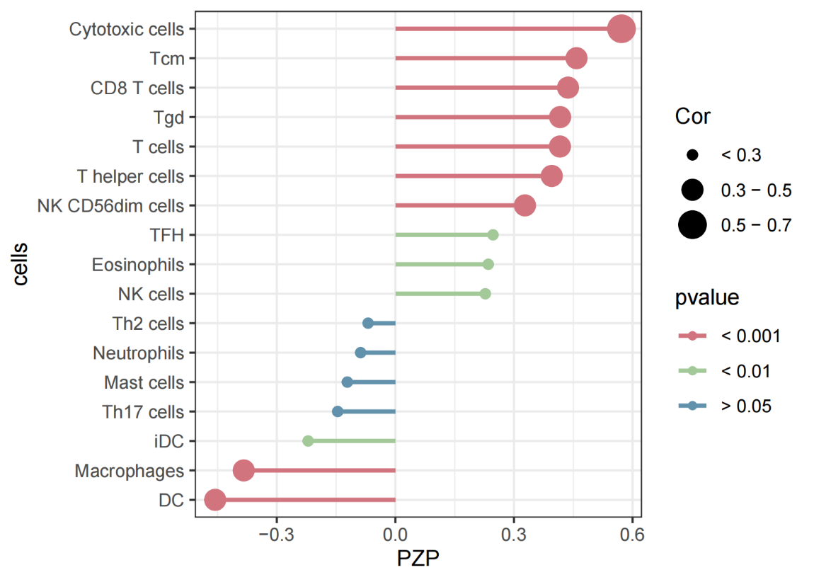

**Supplementary Figure S42.** Lollipop chart showing how PZP is correlated with immune cells in CAD.

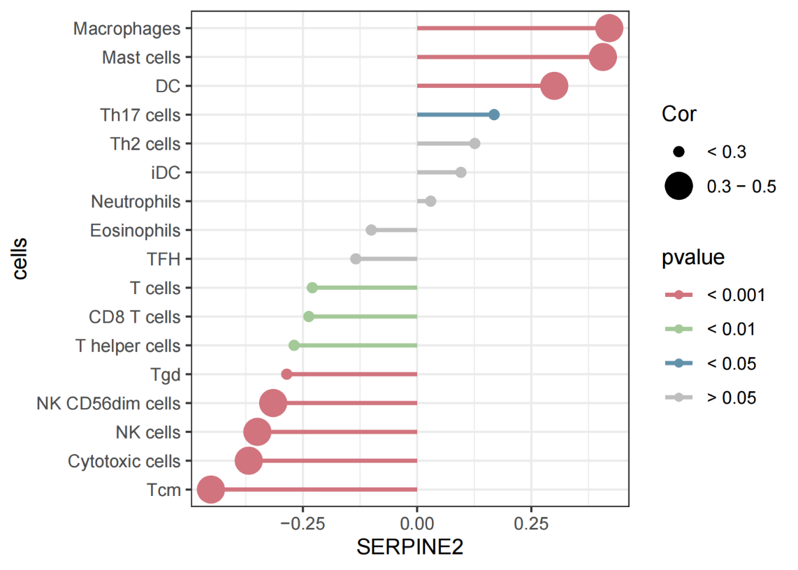

**Supplementary Figure S43.** Lollipop chart showing how SERPINE2 is correlated with immune cells in CAD.

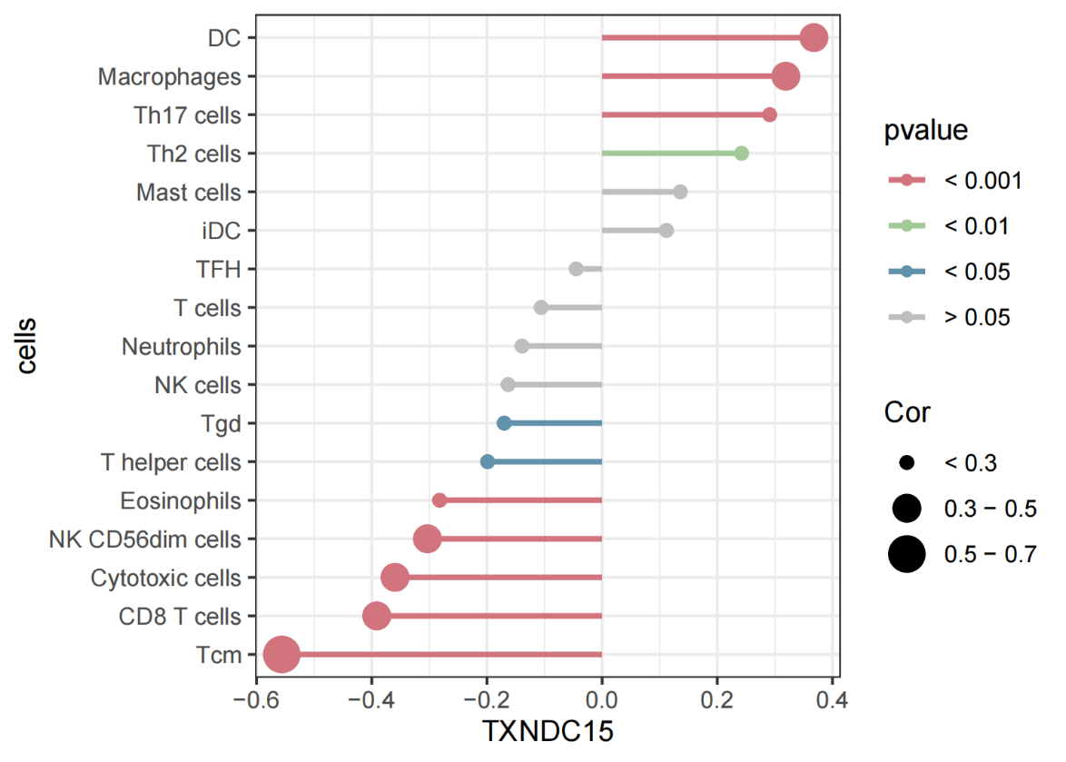

**Supplementary Figure S44.** Lollipop chart showing how TXNDC15 is correlated with immune cells in CAD.

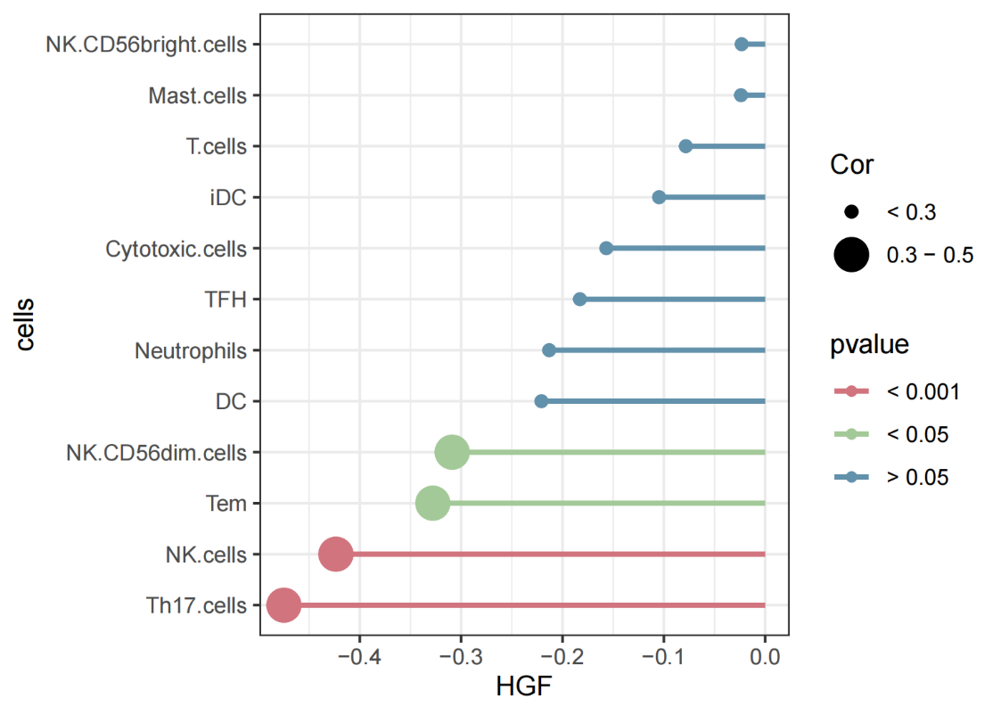

**Supplementary Figure S45.** Lollipop chart showing how HGF is correlated with immune cells in CKD.

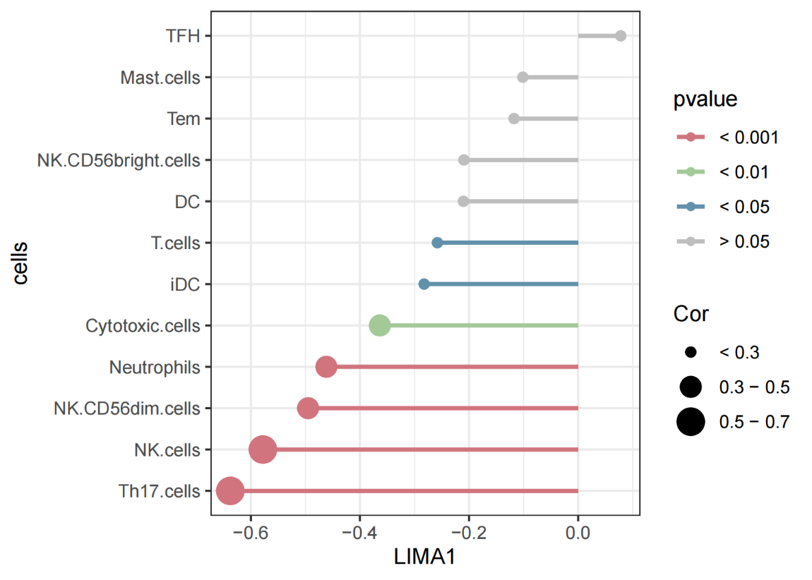

**Supplementary Figure S46.** Lollipop chart showing how LIMA1 is correlated with immune cells in CKD.

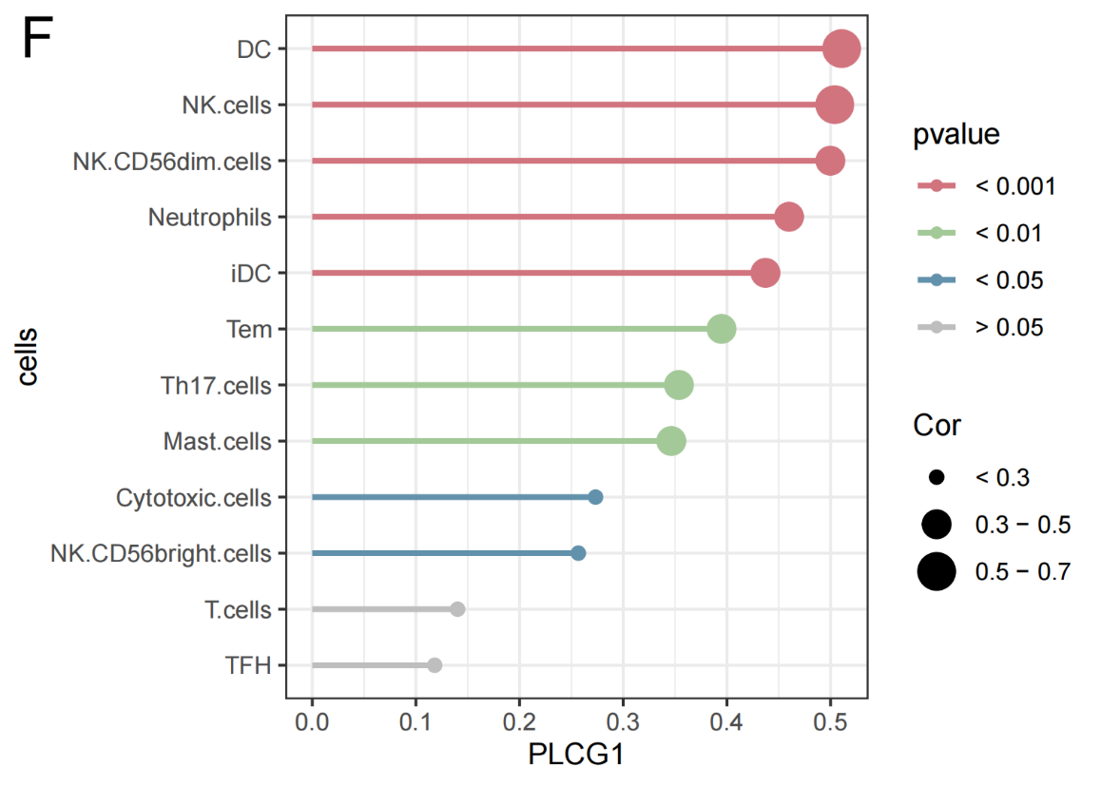

**Supplementary Figure S47.** Lollipop chart showing how PLCG1 is correlated with immune cells in CKD.

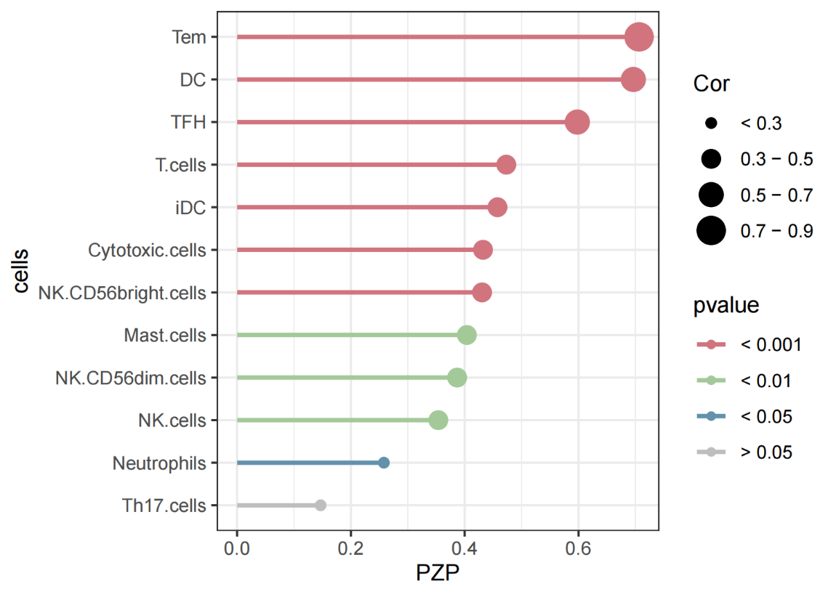

**Supplementary Figure S48.** Lollipop chart showing how PZP is correlated with immune cells in CKD.

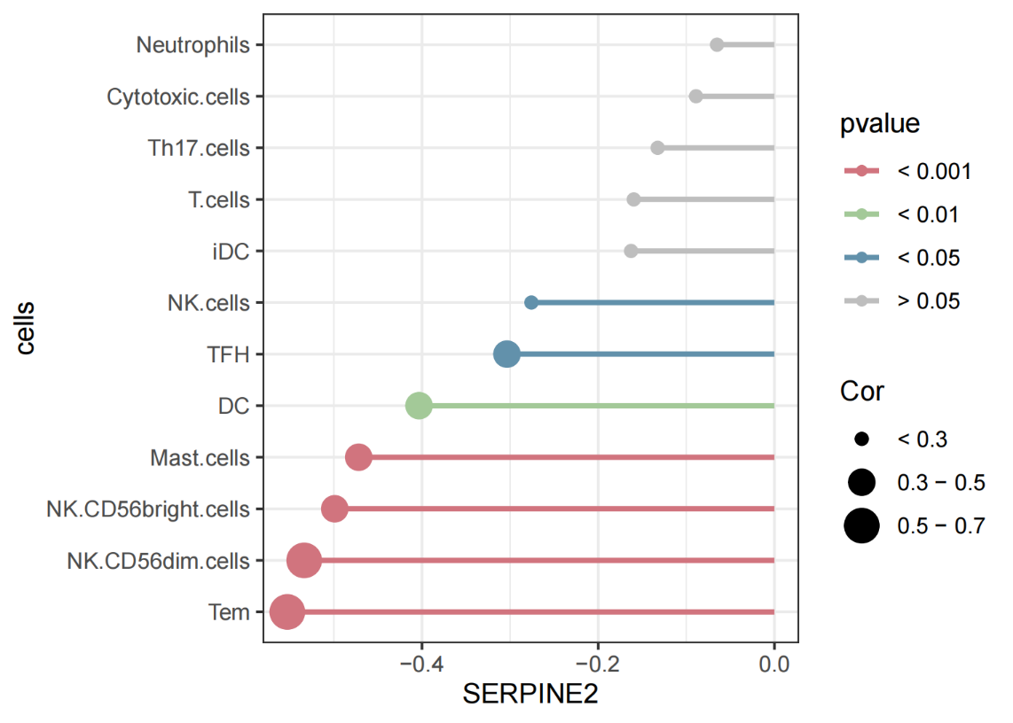

**Supplementary Figure S49.** Lollipop chart showing how SERPINE2 is correlated with immune cells in CKD.

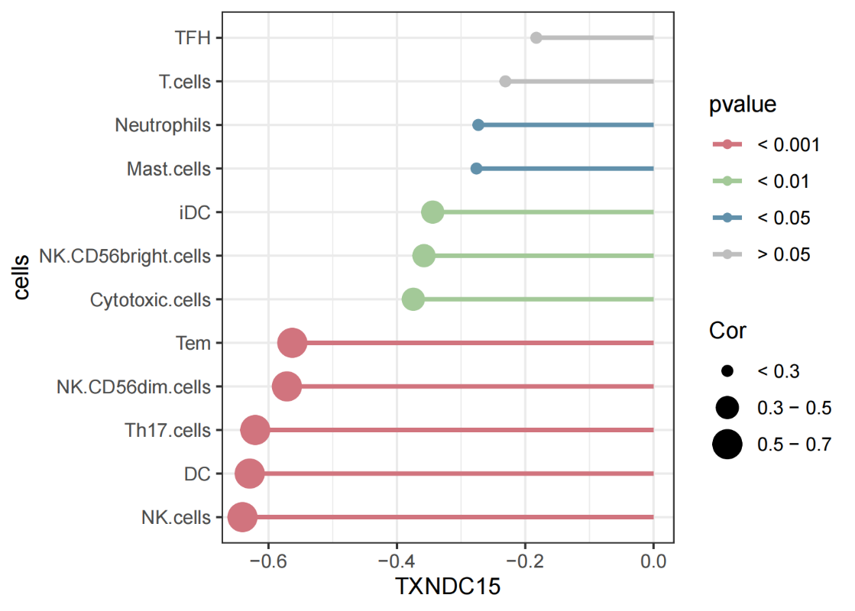

**Supplementary Figure S50.** Lollipop chart showing how TXNDC15 is correlated with immune cells in CKD.

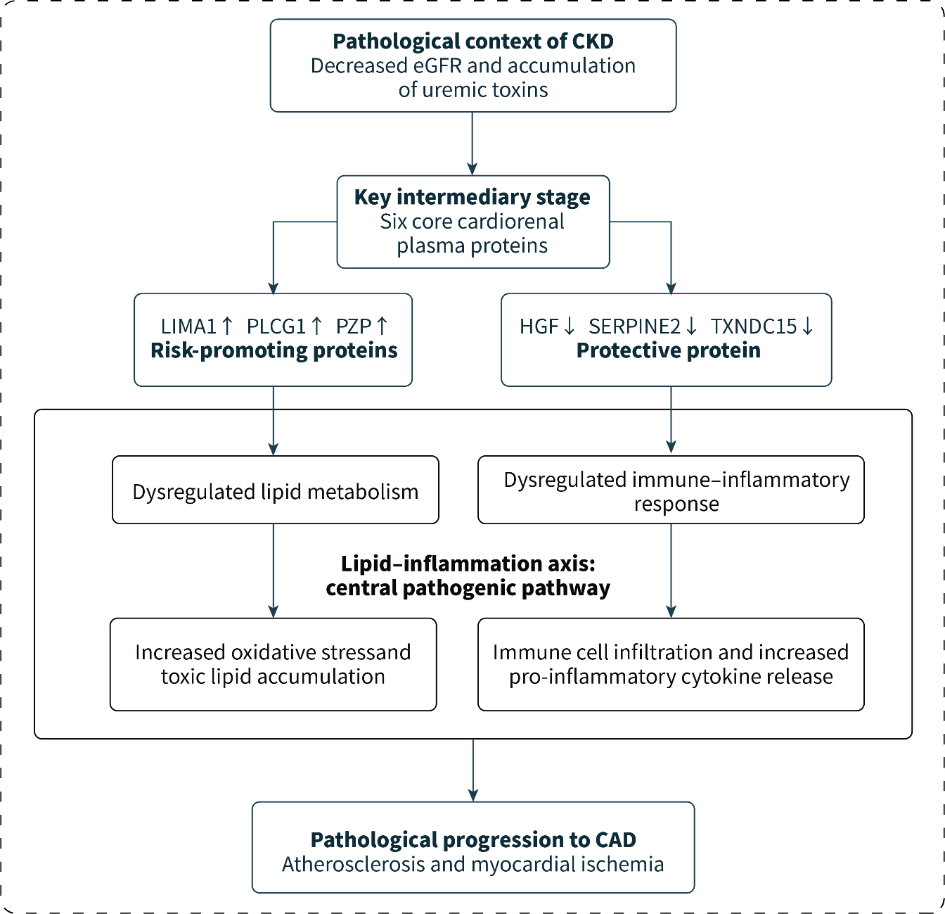

**Supplementary Figure S51.** CKD→Plasma Protein→CAD Lipid-Inflammation Mediation Axis.

## Supplementary Tables

**Table 1** Sensitivity analysis results for CKD–CAD

|  |  |  |  |  |  |  |  |  |  |  |
| --- | --- | --- | --- | --- | --- | --- | --- | --- | --- | --- |
| exposure | method | Q | Q_df | Q_pval | egger_intercept | se | pval | MRPRESSO | correct_causal_direction | steiger_pval |
| CKD | MR Egger | 671.063 | 889 | 1.000 | 0.003 | 0.001 | 0.750 | 1.000 | TRUE | 0 |
| CKD | Inverse variance weighted | 682.133 | 890 | 1.000 | 0.003 | 0.001 | 0.750 | 1.000 | TRUE | 0 |

**Table S1 Sensitivity analysis results for CAD–CKD**

|  |  |  |  |  |  |  |  |  |
| --- | --- | --- | --- | --- | --- | --- | --- | --- |
| exposure | method | Q | Q_df | Q_pval | egger_intercept | se | pval | MRPRESSO |
| CAD | MR Egger | 126.587 | 124 | 0.419 | -0.001 | 0.002 | 0.658 | 0.420 |
| CAD | Inverse variance weighted | 126.788 | 125 | 0.439 | -0.001 | 0.002 | 0.658 | 0.420 |

**Table S2 KEGG Pathway Enrichment Analysis Results of Core Genes**

|  |  |  |  |  |  |  |  |  |  |
| --- | --- | --- | --- | --- | --- | --- | --- | --- | --- |
| category | subcategory | ID | Description | BgRatio | pvalue | p.adjust | qvalue | geneID | Count |
| Environmental Information Processing | Signal transduction | hsa04066 | HIF-1 signaling pathway | 110/8866 | 0.004068 | 0.004068 | 0.075648 | ENO3/PLCG1 | 2 |
| Environmental Information Processing | Signal transduction | hsa04015 | Rap1 signaling pathway | 212/8866 | 0.014491 | 0.014491 | 0.12593 | HGF/PLCG1 | 2 |
| Metabolism | Glycan biosynthesis and metabolism | hsa00531 | Glycosaminoglycan degradation | 19/8866 | 0.017023 | 0.017023 | 0.12593 | IDUA | 1 |
| Environmental Information Processing | Signal transduction | hsa04014 | Ras signaling pathway | 238/8866 | 0.018058 | 0.018058 | 0.12593 | HGF/PLCG1 | 2 |
| Environmental Information Processing | Signal transduction | hsa04020 | Calcium signaling pathway | 254/8866 | 0.020424 | 0.020424 | 0.126605 | HGF/PLCG1 | 2 |
| Environmental Information Processing | Signal transduction | hsa04010 | MAPK signaling pathway | 300/8866 | 0.027919 | 0.027919 | 0.139427 | HGF/MAX | 2 |
| Metabolism | Metabolism of cofactors and vitamins | hsa00860 | Porphyrin metabolism | 46/8866 | 0.040777 | 0.040777 | 0.139427 | UROS | 1 |

**Table S4 Sensitivity analysis of CKD–diagnostic protein pQTLs**

|  |  |  |  |  |  |  |  |
| --- | --- | --- | --- | --- | --- | --- | --- |
| outcome | method | Q | Q_df | egger_intercept | se | pval | MRPRESSO |
| HGF | MR Egger | 1320.330 | 1329 | -0.004 | 0.001 | 0.164 | 0.328 |
| HGF | Inverse variance weighted | 1338.220 | 1330 | -0.004 | 0.001 | 0.164 | 0.328 |
| LIMA1 | MR Egger | 1245.044 | 1329 | 0.004 | 0.001 | 0.414 | 0.827 |
| LIMA1 | Inverse variance weighted | 1269.374 | 1330 | 0.004 | 0.001 | 0.414 | 0.827 |
| PLCG1 | MR Egger | 1159.167 | 1329 | 0.003 | 0.001 | 0.499 | 0.998 |
| PLCG1 | Inverse variance weighted | 1170.040 | 1330 | 0.003 | 0.001 | 0.499 | 0.998 |
| PZP | MR Egger | 4019.407 | 1329 | 0.007 | 0.001 | 0.419 | 0.838 |
| PZP | Inverse variance weighted | 4094.375 | 1330 | 0.007 | 0.001 | 0.419 | 0.838 |
| SERPINE2 | MR Egger | 1919.563 | 1329 | 0.000 | 0.001 | 0.768 | 0.534 |
| SERPINE2 | Inverse variance weighted | 1919.689 | 1330 | 0.000 | 0.001 | 0.768 | 0.534 |
| TXNDC15 | MR Egger | 1269.285 | 1329 | -0.003 | 0.001 | 0.457 | 0.912 |
| TXNDC15 | Inverse variance weighted | 1278.464 | 1330 | -0.003 | 0.001 | 0.457 | 0.912 |